Capstone Project Final Report

Title of Capstone Project:
AI-Powered Career and Skill-Gap Recommendation System Using Canadian Job Bank Data, O*NET Occupational Information, and CIP Educational Pathways.

Group 1:
Alveera Malik
Ansu Joy
Arya Unni
Jasmine Jose
Souren Chowdhury

Course: Capstone Project (DAMO-699-1)
Program: Master of Data Analytics, University of Niagara Falls Canada
Instructor: Mehdi Mostofi

Date: September 09, 2026
Executive Summary
This capstone project presents the development of an AI-powered career advisor and skill-gap recommendation system. It is designed to provide personalized, explainable, and evidence-based career guidance. The system addresses the limitations of traditional keyword-based approaches by combining candidate information with Government of Canada Job Bank data, O*NET occupational information, and CIP education pathways.
The system integrates different factors such as skill matching, semantic similarity, labour-market demand, and education alignment to recommend suitable occupations. It also identifies priority skill gaps and provides source-grounded career explanations using a retrieval-based evidence framework. The completed solution was deployed through a Streamlit application.
The validated project evaluated 63 candidates across 15 occupations that produces 945 candidate–occupation combinations. The average Top-1 hybrid recommendation score was 78.18%, while the average skill match was 96.06%. Human evaluation showed an 88.42% F1 score for skill extraction, 88.00% Precision@5 and 97.82% NDCG@5 for recommendation ranking, and 69.16% F1 for skill-gap identification. The average expert rating for skill-gap outputs was 4.84/5, while RAG explanations performed even better and received an overall 5.00/5 rating within the evaluated sample.
The findings demonstrate the feasibility of combining candidate profiles, occupational requirements, labour-market intelligence, education pathways, semantic matching, and evidence retrieval that will support personalized career decision-making.
The study recognizes several limitations that are related to dataset size, resume extraction, occupational mapping, changing labour-market conditions, limited labelled data, and semantic modelling. Future research can be built on this work by expanding the available datasets, improving the semantic matching models, connecting the system to real-time labour-market data, and further developing the deployed Streamlit application. These improvements would make the system more robust and current and would be useful for a wider range of candidates and career situations.
Overall, this project provides a practical foundation for personalized and explainable career guidance, helping connect a candidate’s skills and background with suitable occupations and meaningful skill-development opportunities.
Acknowledgements
The completion of this capstone project would not have been possible without the guidance, support, and encouragement we received throughout our project.
The group members would like to express sincere appreciation to the capstone project instructor Dr. Mehdi Mostofi (PhD, DACP, CAE, CSCM, CCI) for his valuable guidance, feedback, and inspiration. We are also thankful to the faculty members of the Master of Data Analytics program at the University of Niagara Falls Canada for their valuable suggestions and academic support.
The team also gratefully acknowledges the contributions of publicly available data providers, including the Government of Canada Job Bank, the O*NET Resource Center, and the National Center for Education Statistics (NCES), whose datasets supported the development and evaluation of this project.
Finally, we extend our heartfelt thanks to everyone who generously shared their time, knowledge, and feedback during the research and development process.

Table of Contents
Chapter 1 - Introduction 10
1.1 Background and Context 10
1.2 Problem Statement 11
1.3 Research Problem 11
1.4 Research Questions 12
1.5 Hypothesis 13
1.6 Objectives 13
1.7 Project Scope 14
1.8 Stakeholders 15
1.9 Success Criteria and Project Risks 15
1.10 Report Organization 17
Chapter 2 - Literature Review 18
2.1 Introduction 18
2.2 AI-Based Career Recommendation Systems 18
2.3 Retrieval-Augmented Generation for Career Guidance 19
2.4 NLP-Based Skill Matching and Occupational Recommendation 20
2.5 Labour-Market and Occupational Data Integration 20
2.6 Research Gap 21
Chapter 3 - Methodology and Research Design 21
3.1 Introduction 21
3.2 Research Design 22
3.3 Analytics Framework 22
3.4 Data Sources and Integration 23
3.5 Recommendation System Development 23
3.6 Skill-Gap and Learning-Pathway Analysis 24
3.7 Retrieval-Augmented Generation 24
3.8 Evaluation Methodology 24
3.9 Ethical Considerations 25
Chapter 4 - Data Collection and Data Understanding 25
4.1 Data Sources 25
4.2 Occupational Classification Integration 26
4.3 Job Bank Dataset Understanding 27
4.4 Data Quality Assessment 28
4.5 Preliminary Occupation Analysis 29
Chapter 5 - Occupational Data Selection, Analysis, and O*NET & CIP Integration 30
5.1 Occupation Selection 30
5.2 Regional Classification 32
5.3 Diagnostic Labour-Market Analysis 32
5.4 Education Requirements Analysis 34
5.5 Experience and Employment Type Analysis 35
5.6 Demand Drivers 37
5.7 Experience and Salary Analysis 37
5.8 Salary and Vacancy Relationship 38
5.9 Occupation and Education Association 38
5.10 O*NET Occupational Integration 39
5.11 O*NET Education, Training, and Job Zone Integration 40
5.12 CIP 2020 Educational Pathway Integration 41
5.13 Integrated O*NET and CIP Occupational Profile 42
Chapter 6 - Candidate Profiling, Baseline Occupation Recommendation, and Initial Model Analysis 43
6.1 Candidate Profiling 43
6.2 Baseline Occupation Recommendation 44
6.3 Score Distribution and Recommendation Behaviour 45
6.4 Data-Quality and Model Behaviour Observations 45
6.5 Baseline Evaluation 46
Chapter 7 - Multi-Factor Recommendation Engine Development and Model Evaluation 47
7.1 Multi-Factor Recommendation Engine 47
7.2 Keyword and TF-IDF Recommendation Models 47
7.3 Sentence-Transformer Semantic Recommendation 48
7.4 Labour-Market Demand and Education Alignment 49
7.5 Final Hybrid Recommendation Model 49
7.6 Model Comparison and Recommendation Transition 50
7.7 Recommendation Review and Error Diagnostics 51
7.8 Validation and Exported Recommendation Outputs 51
7.9 Summary of Week 6 Model Results 52
Chapter 8 - RAG-Based Career Advisory System Development and Integration 53
8.1 Introduction 53
8.2 RAG System Architecture 54
8.3 Development of the RAG Knowledge Base 54
8.4 Semantic Embedding and Vector Index 55
8.5 Semantic Evidence Retrieval 56
8.6 Candidate-Specific Evidence and Grounded Explanations 57
8.7 Evidence Traceability and Responsible Generation 58
8.8 Integration with the Career Recommendation System 59
8.9 Human Evaluation Framework 60
8.10 RAG Error Analysis 61
8.11 Development Outcome 61
Chapter 9 - Deployment And Final System Analysis 62
9.1 Introduction 62
9.2 Deployment Architecture and Integration 62
9.3 Top-5 Career Recommendation Integration 63
9.4 Prescriptive Skill-Gap Integration 64
9.5 RAG Explanation Integration and Alignment 65
9.6 Final Project KPIs 66
9.7 Final Business and Research Insights 67
9.8 Deployment Artifacts 68
9.9 Reproducibility and Integrity Validation 69
9.10 Deployment Outcome 70
10.1 Human Evaluation Dataset and Completeness 71
10.2 Skill Extraction and Skill-Gap Evaluation 72
10.3 Career Recommendation Ranking Evaluation 73
10.4 RAG Human Evaluation 73
10.5 Consolidated Evaluation and Final Validation 74
Chapter 11 - Streamlit Application and Deployment 76
11.1 Application Architecture 76
11.2 Data Loading and Deployment Configuration 76
11.3 Candidate Input and Resume Processing 76
11.4 Career Recommendation and Skill-Gap Interface 77
11.5 Grounded Career Explanation 78
11.6 Dashboard and Human-Evaluation Results 78
Chapter 12 - Contributions, Limitations, Future Directions, and Conclusion 80
12.1 Contributions of the Study 80
12.2 Strategic and Practical Implications 80
12.3 Limitations of the Study 81
12.4 Future Directions 82
12.5 Conclusion 82
References 84

List of Tables
Table 1 15
Table 2 16
Table 3 26
Table 4 28
Table 5 29
Table 6 31
Table 7 33
Table 8 37
Table 9 37
Table 10 38
Table 11 38
Table 12 39
Table 13 39
Table 14 40
Table 15 42
Table 16 43
Table 17 44
Table 18 44
Table 19 45
Table 20 46
Table 21 48
Table 22 48
Table 23 49
Table 24 50
Table 25 53
Table 26 55
Table 27 58
Table 28 67
Table 29 68
Table 30 69
Table 31 74
List of Figures
Figure 1 30
Figure 2 31
Figure 3 32
Figure 4 32
Figure 5 33
Figure 6 34
Figure 7 35
Figure 8 36
Figure 9 36
Figure 10 51
Figure 11 56
Figure 12 59
Figure 13 60
Figure 14 63
Figure 15 65
Figure 16 65
Figure 17 70
Figure 18 71
Figure 19 72
Figure 20 73
Figure 21 73
Figure 22 75
Figure 23 77
Figure 24 78
Figure 25 79
List of Abbreviations
Abbreviation | Full Form
AI | Artificial Intelligence
NLP | Natural Language Processing
RAG | Retrieval-Augmented Generation
LLM | Large Language Model
ML | Machine Learning
TF-IDF | Term Frequency-Inverse Document Frequency
NOC | National Occupational Classification
SOC | Standard Occupational Classification
CIP | Classification of Instructional Programs
O*NET | Occupational Information Network
CRISP-DM | Cross-Industry Standard Process for Data Mining
API | Application Programming Interface
CSV | Comma-Separated Values
SQL | Structured Query Language
EDA | Exploratory Data Analysis
F1-score | Harmonic Mean of Precision and Recall
MRR | Mean Reciprocal Rank
NDCG | Normalized Discounted Cumulative Gain
RAG | Retrieval-Augmented Generation
U.S. | United States
LMI | Labour Market Information

Chapter 1 - Introduction

1.1 Background and Context
The Canadian labour market is continually changing due to technological advancement, digitalization, automation, and evolving workforce requirements. These continuous changes have increased the importance of aligning individual skills and competencies with what employers actually want in today’s emerging occupational demands. As a result, students, graduates, newcomers, and experienced professionals increasingly need career advice that looks at the big picture - combining their education and experience with real-time market trends.
Traditional career counselling and many digital job-matching platforms rely substantially on keyword matching. They usually look for overlapping words between candidate profiles and occupation or job descriptions. This approach can identify direct similarities. But, it may miss to view broader relationships such as how transferable skills, occupational requirements, educational background, and labour-market demand actually connect with each other. As a result, these recommendations may not fully reflect an individual's potential career pathways or skill-development needs.
The availability of occupational, labour-market, and educational datasets provides an opportunity to develop more evidence-based career recommendation systems. Advances in artificial intelligence (AI), natural language processing (NLP) and machine learning (ML) further support the analysis and integration of these diverse sources.
This project develops an AI-powered career recommendation and skill-gap analysis system for the Canadian labour market. It integrates the Government of Canada Job Bank, O*NET, and the Classification of Instructional Programs (CIP) to support occupation matching, skill-gap identification, and learning-pathway exploration. The proposed system is designed as a decision-support tool that can provide personalized and evidence-based information to support career planning.

1.2 Problem Statement
Finding a suitable career is not about simply matching a resume with a job description. Candidates may have transferable skills. These skills are relevant to occupations even when the same keywords are not present. A keyword-based approach may therefore miss potentially suitable career options.
Another challenge is that career recommendations often stop after identifying a possible occupation. They may not clearly show factors such as which skills a candidate already has and where gaps exist. They also do not advise what learning could help address those gaps.
Career decisions also depend on practical factors such as labour-market demand and available educational pathways. Considering these factors separately makes it even harder to assess overall career suitability.
This project aims to address these challenges by developing an AI-powered career recommendation and skill-gap analysis system. The system brings together a candidate’s skills with occupational requirements, labour-market demand, and relevant educational pathways. In this way, the recommendations can be more relevant to the individual and, importantly, practical, understandable, and useful for planning the next steps in their career.

1.3 Research Problem
The research problem addressed in this project is the limited ability of existing career recommendation systems to provide personalized, explainable, and evidence-supported career guidance by considering multiple dimensions of an individual's profile and external career information. Traditional recommendation approaches often focus on direct similarity between candidate profiles and job descriptions, which may not adequately capture occupational requirements, labour-market conditions, and potential career development pathways.
This research investigates whether an integrated AI-powered career recommendation framework can improve the quality of career recommendations and skill-gap analysis. This is performed by combining candidate information with occupational, labour-market, and educational data. Specifically, the study examines the effectiveness of integrating Government of Canada Job Bank labour-market information, O*NET occupational characteristics, and Classification of Instructional Programs (CIP) educational pathways with machine learning, natural language processing (NLP), semantic similarity methods, and Retrieval-Augmented Generation (RAG).
The research evaluates weather this integrated approach can provide important aspects like more relevant occupation rankings, identify candidate skill gaps more accurately, and generate evidence-supported career recommendations compared with traditional keyword-based matching methods.

1.4 Research Questions
The primary research question guiding this study is:
RQ1: How can NLP-based skill matching, semantic similarity, Canadian labour-market demand, education alignment, skill-gap analysis, and retrieval-based evidence be integrated to generate explainable and actionable career recommendations?
To address the primary research question, the following secondary research questions are investigated:
RQ2: Which selected occupations have the most postings and vacancies in Canada?
RQ3: How does the demand for selected occupations differ across provinces or territories?
RQ4: Which O*NET knowledge areas, skills, and abilities are most important for selected positions?
RQ5: What educational programs are associated with the selected occupations based on the CIP-SOC crosswalk?
RQ6: How accurately can the system identify skills, education, experience, certifications and projects from the resumes of the selected applicants?

1.5 Analytical Expectation
This study examines whether integrating labour-market information, occupational requirements, educational pathways, NLP-based skill matching, semantic similarity, skill-gap analysis, and retrieval-based evidence can provide more comprehensive and explainable career recommendations than traditional keyword-based matching approaches.
Rather than testing statistical significance through formal hypothesis testing, the project evaluates this expectation using model comparison, recommendation-ranking metrics, skill-extraction and skill-gap evaluation, and human assessment of the source-grounded career explanations.

1.6 Objectives
The main objective of this project is to develop an AI-powered system that can provide personalized career recommendations and help candidates understand their skill gaps.
The specific objectives are to:
- Build an AI-powered career recommendation engine using candidate, occupation, labour-market, and education data.
- Develop and evaluate different recommendation models for matching candidates with suitable occupations.
- Compare candidate skills with occupational requirements to identify skill gaps.
- Identify and prioritize missing occupational skills and provide skill-development guidance using occupational and education evidence.
- Develop a retrieval-based career explanation system using semantic embeddings and FAISS to provide source-grounded explanations for career recommendations.
- Create an interactive dashboard to present career recommendations, labour-market insights, and skill-gap results.

1.7 Project Scope
The aim of the capstone project is to design, develop and evaluate an Artificial Intelligence (AI)-based career guidance suggestion and skill-gap identification tool to improve the career guidance for students, new graduates and job seekers in Canada. The system will connect three official data sources: Government of Canada Job Bank, O*NET, and Classification of Instructional Programs (CIP) to bring together knowledge about labour market demand, occupational requirements and the education pathways, and offer evidence-based career insights. In particular, the project will be informed by 15 specialized occupations in the Canadian domain of data, technology and business analytics. It will link Canadian occupations with the O*NET and CIP using the official crosswalk files and the National Occupational Classification (NOC) 2021 classification. The system will analyse the need for labour, compare skills, education and experience of the participants with an appropriate occupation, identify gaps in skills and experiences of the participants and recommend suitable educational paths and personalize advice on the career, and create individual career plans. There will be an interactive Streamlit application to implement the final solution. The project is limited to the activity of the career recommendation and the skill gap analysis and is intended to assist the decision-making process for career. It will not guarantee a job placement or career development counselling or career success. It is intended to give reliable, interpretable and data-driven recommendations, rather than relying solely on simple keyword matching.

1.8 Stakeholders
The main users of this project will be students, recent graduates, and job seekers in Canada looking for tailored and evidence-informed career guidance. The designed system will assist them to determine appropriate career options, assess skill gaps and design relevant educational trajectories in response to the existing demand for jobs in the labour market. The system can be useful to universities, colleges and career service departments to assist with academic advising and career counselling. A workforce better equipped for industry skills needs can also benefit employers and recruitment organisations. Further, the integrated analysis of Job Bank, O*NET, and CIP data can provide researchers and policymakers with insights that can be used to inform labour-market research and workforce planning. The goal of the system is to deliver trustworthy, understandable, and data-informed recommendations for careers that will ultimately serve the needs of both individuals and organizations in education and workforce development.

1.9 Success Criteria and Project Risks
Success Criteria
The success of this project will be evaluated based on the ability of the proposed system to generate relevant, personalized, and evidence-supported career recommendations. The evaluation will consider both recommendation performance and the quality of supporting analytical components.
Table 1
Initial/project-planning success criteria
Evaluation Metric | Target
Top 3 occupation recommendation accuracy | ≥ 80%
Skill extraction F1-score | ≥ 0.75
Semantic model improvement | Outperforms keyword-based matching
RAG evidence-grounded responses | ≥ 85% factual support

These criteria provide measurable benchmarks for assessing the effectiveness of the recommendation models, skill-gap analysis, and AI-generated career explanations.
Project Risks and Mitigation
Key project risks and corresponding mitigation strategies are summarized in Table 2.
Table 2
Project Risks, Potential Impacts, and Mitigation Strategies
Risk | Potential Impact | Mitigation Strategy
Inaccurate occupation mapping between NOC and O*NET | Incorrect career recommendations | Use official crosswalk files and manually validate mappings for selected occupations.
Large project scope | Increased complexity and delayed completion | Limit the project to 10–20 occupations within the Canadian data, technology, and business analytics domain.
Missing or inconsistent data | Reduced accuracy of analysis and recommendations | Perform comprehensive data cleaning, preprocessing, and missing-value analysis before modelling.
Differences between Canadian and U.S. occupational classifications | Mapping errors between datasets | Use official NOC–SOC and SOC–O*NET crosswalk files and document mapping limitations.
Privacy concerns when processing resumes | Exposure of personal information | Use anonymized candidate profiles, remove personal identifiers, and obtain participant consent where required.
AI-generated recommendations may contain unsupported information | Reduced trust and reliability | Use Retrieval-Augmented Generation (RAG) with evidence retrieved from trusted datasets and display supporting sources.
Changes in labour-market demand over time | Recommendations may become outdated | Use the latest available Government of Canada Job Bank data and document the data version used in the analysis.

1.10 Report Organization
This report is organized into twelve chapters.
Chapter 1 introduces the research problem, objectives, scope, and research questions.
Chapter 2 reviews literature on AI career recommendation, NLP, skill gaps, and Retrieval-Augmented Generation (RAG).
Chapter 3 presents the methodology, data sources, analytical framework, and evaluation approach.
Chapter 4 describes data collection, data understanding, and exploratory analysis.
Chapter 5 presents occupational data selection, analysis, and O*NET and CIP integration, establishing the occupational reference dataset used in the subsequent stages of the study.
Chapter 6 presents candidate profiling, the baseline recommendation approach, skill-gap analysis, and the evaluation of the recommendation approaches.
Chapter 7 presents Multi-Factor Recommendation Engine Development and Model Evaluation.
Chapter 8 presents RAG-Based Career Advisory System Development and Integration.
Chapter 9 presents deployment architecture, final KPIs, business insights, and integrity validation.
Chapter 10 summarizes human evaluation results and consolidated final validation.
Chapter 11 describes the Streamlit application, deployment configuration, and user interface. Chapter 12 concludes with contributions, limitations, future directions, and the final conclusion.

Chapter 2 - Literature Review

2.1 Introduction
This chapter reviews existing researches on AI-based career recommendation, NLP-based skill matching, Retrieval-Augmented Generation (RAG), and occupational data integration. It identifies key limitations in existing approaches and establishes the research gap addressed by this project.

2.2 AI-Based Career Recommendation Systems
Machine learning has increasingly been applied to improve career recommendation and prediction. Roy and Sharma (2026) proposed an AI-powered career guidance framework that combined Holland's RIASEC model with Decision Tree, Support Vector Machine (SVM), and XGBoost algorithms. Using more than 81,000 career profiles, the study applied data preprocessing, feature engineering, and model optimization with XGBoost and it achieved the strongest performance. The framework also incorporated visual analytics to improve interpretability.
The study demonstrates the potential of ML. It provides more scalable and personalized career guidance than traditional approaches. However, it primarily relied on psychometric assessment data. It did not incorporate resume analysis, RAG, LLMs, or real-time labour-market information. These limitations highlight the need for more comprehensive and context-aware career recommendation systems.
Roy, M., & Sharma, K. (2026). AI-Powered Career Guidance: A Scalable Model for Personalized Recommendations. IEEE Access.
https://www.researchgate.net/publication/400558524_AI-Powered_Career_Guidance_A_Scalable_Model_for_Personalized_Recommendations

2.3 Retrieval-Augmented Generation for Career Guidance
Large Language Models (LLMs) provide new opportunities for conversational career guidance but may generate inaccurate or unsupported information. Retrieval-Augmented Generation (RAG) addresses this limitation. It is performed by retrieving relevant external information before generating responses.
Tolegen (2025) developed a RAG-based career guidance system. The system used a curated knowledge base, LLaMA-3, sentence-transformer embeddings, and the Annoy vector database. To see the result, evaluation of 100 career-related queries was performed. It showed that the RAG-enhanced system performed better than the baseline LLM in areas including relevance, empathy, and factual grounding.
Although the study demonstrated the potential of RAG for more reliable career guidance, its primary focus was high-school counselling. It did not integrate resume-based candidate profiling, occupation-ranking models, prescriptive skill-gap analysis, Canadian labour-market demand, or education-alignment information within a single career decision-support framework. These limitations highlight an opportunity for a more integrated approach that combines career recommendation, skill-gap identification, labour-market evidence, educational alignment, and retrieval-based occupational explanations.
Reference
Tolegen, A. (2025). RAG for AI-Powered Career Guidance in High Schools: A Pilot Study.
https://nhsjs.com/2025/rag-for-ai-powered-career-guidance-in-high-schools-a-pilot-study/

2.4 NLP-Based Skill Matching and Occupational Recommendation
NLP techniques are increasingly used to match candidate profiles with occupational requirements. Traditional keyword matching is simple and transparent. But the technique may overlook differences in terminology and contextual meaning. Our proposed methods which are Term Frequency-Inverse Document Frequency (TF-IDF), sentence embeddings, and semantic similarity can provide more flexible matching of skills, experience, and occupational requirements.
For example, semantic matching can associate a candidate's "payment processing" experience with occupations requiring transaction management or financial operations skills. These approaches provide a foundation for developing occupation-ranking models that move beyond exact keyword matching.

2.5 Labour-Market and Occupational Data Integration
To make effective career recommendations, more than candidate-profile matching is needed. The key factors like labour-market demand, occupational requirements, and educational pathways provide important context during evaluating realistic career options.
We have used three main data sources. First source is the Government of Canada Job Bank. It provides information on employment demand, vacancies, wages, and regional opportunities. The second source is O*NET which provides detailed occupational information, including skills, knowledge, abilities, tasks, and work activities. Third source is CIP which has standardized information on educational programs and fields of study.
By bringing these sources together, the study can support evidence-based recommendations by combining candidate suitability with labour-market demand and relevant educational pathways.

2.6 Research Gap
Existing research demonstrates the value of AI, ML, NLP, and RAG in career guidance. However, these approaches often address individual components rather than integrating the complete career decision-making process.
ML-based systems may focus on career prediction using assessment data. RAG systems primarily improve conversational guidance. NLP-based systems often emphasize text similarity without incorporating labour-market demand, occupational requirements, or educational pathways.
This project addresses this gap by integrating:
- Government of Canada Job Bank labour-market information;
- O*NET occupational skills and requirements;
- CIP educational pathways;
- NLP-based candidate profile analysis;
- occupation recommendation models;
- skill-gap identification; and
- RAG-based evidence-grounded explanations.
The proposed framework aims to provide personalized, explainable, and data-driven career guidance for students, graduates, and job seekers in Canada.

Chapter 3 - Methodology and Research Design

3.1 Introduction
This chapter describes the methodology used to develop and evaluate the AI-powered career recommendation and skill-gap analysis system. The study combines data preparation, labour-market analysis, occupational analysis, recommendation modelling, and system evaluation.

3.2 Research Design
The project follows a design-oriented analytics approach in which a career recommendation system is developed and evaluated through a series of stages:
- Data collection and preparation
- Labour-market and occupational analysis
- Occupational data integration and mapping
- Recommendation model development
- Skill-gap and learning-pathway analysis
- System integration and evaluation
The overall approach examines whether combining candidate information with occupational, labour-market, and educational data can produce more useful career recommendations than simple keyword matching.

3.3 Analytics Framework
Four forms of analytics are applied throughout the project.
3.3.1 Descriptive Analytics
Descriptive analysis is used to examine Canadian labour-market conditions by using Government of Canada Job Bank data. The analysis considers job demand, vacancies, wages, geographic distribution, and employment requirements.
3.3.2 Diagnostic Analytics
Diagnostic analysis examines factors that influence occupational suitability. This includes differences in labour demand, occupational skill requirements, education requirements, and candidate–occupation mismatches.
3.3.3 Ranking Analytics
The predictive component ranks occupations according to candidate suitability rather than predicting guaranteed employment outcomes. Several recommendation approaches are evaluated, including keyword matching, TF-IDF similarity, semantic similarity, and multi-factor recommendation scoring.
3.3.4 Prescriptive Analytics
Prescriptive analysis converts recommendation results into practical career guidance. The system identifies suitable occupations, skill gaps, priority areas for development, and relevant educational pathways.

3.4 Data Sources and Integration
Three primary data sources are used in the project:
- Government of Canada Job Bank - Canadian labour-market information, including demand, wages, vacancies, locations, and employment requirements.
- O*NET Occupational Database - Occupational skills, knowledge, abilities, tasks, and work-related requirements.
- Classification of Instructional Programs (CIP) - Educational program classifications used to identify relevant learning pathways.
Occupational information is connected using available classification crosswalks between NOC, SOC, O*NET-SOC, and CIP. Selected mappings are reviewed to reduce classification errors.

3.5 Recommendation System Development
The recommendation system uses a content-based ranking approach. Candidate profiles are analysed using information such as education, work experience, technical and professional skills, projects, and certifications.
The recommendation process is developed progressively:
- Keyword-based matching
- TF-IDF textual similarity
- Sentence-Transformer semantic similarity
- Labour-market demand adjustment
- CIP-based education alignment
- Multi-factor hybrid recommendation scoring
The final model combines skill-based candidate–occupation matching, semantic similarity, Canadian labour demand, and CIP-based education alignment to produce ranked occupation recommendations.

3.6 Skill-Gap and Learning-Pathway Analysis
The system compares candidate skills with the skills and requirements associated with recommended occupations. This comparison identifies areas where candidates may require additional development.
The identified gaps are connected with relevant educational programs, certifications, or learning areas using the integrated occupational and CIP information.

3.7 Retrieval-Augmented Generation
A Retrieval-Augmented Generation (RAG) component is used to support evidence-based career guidance. The system retrieves relevant information from trusted occupational, labour-market, and educational sources before generating career-related responses.
The RAG component provides explanations related to occupation recommendations, skill gaps, educational pathways, and supporting evidence.

3.8 Evaluation Methodology
The recommendation approaches are evaluated using multiple criteria, including:
- Top-K accuracy
- Precision@K
- Recall@K
- Mean Reciprocal Rank (MRR)
Additional evaluation examines recommendation changes between models, score behaviour, validation results, and potential recommendation errors.
Skill extraction performance is measured using: Precision, Recall & F1-score.
RAG responses are evaluated based on: Relevance, Correctness, Groundedness & Source support.

3.9 Ethical Considerations
In this project, we considered privacy, transparency, data quality, occupational-mapping limitations, potential bias, and the risk of unsupported AI-generated information.
Candidate information is handled using anonymized profiles where possible. The system is intended as a decision-support tool, rather than a guarantee of employment, career success, or professional counselling.

Chapter 4 - Data Collection and Data Understanding

4.1 Data Sources
The project integrates three primary data sources to combine Canadian labour-market information, occupational requirements, and educational pathways.
4.1.1 Government of Canada Job Bank
Source: Government of Canada - Job Bank
Website: https://www.jobbank.gc.ca/home
Labour Market Information: https://www.jobbank.gc.ca/trend-analysis
The Job Bank dataset provides Canadian labour-market information. This includes job postings, vacancy counts, occupations, geographic distribution, wages, employment characteristics, and qualification requirements. It is the primary source for analysing Canadian labour-market demand.

4.1.2 O*NET Occupational Database
Source: O*NET Resource Center, U.S. Department of Labor
Website: https://www.onetcenter.org/database.html
O*NET provides detailed occupational information, including skills, knowledge, abilities, tasks, work activities, and technology requirements. These attributes support occupational profiling and candidate skill-gap analysis.
4.1.3 Classification of Instructional Programs (CIP)
Source: National Center for Education Statistics (NCES), U.S. Department of Education
Website: https://nces.ed.gov/ipeds/cipcode/
CIP provides standardized classifications of educational programs and fields of study. The dataset supports the identification of relevant education pathways associated with selected occupations.

4.2 Occupational Classification Integration
Because the datasets use different classification systems, official crosswalks were used to establish relationships between Canadian occupations, U.S. occupational classifications, O*NET occupations, and educational programs.
The primary mapping structure was:
NOC 2021 → NOC 2016 → SOC 2018 → O*NET-SOC
CIP programs were additionally mapped to SOC 2018 occupations.
Table 3
The following official crosswalks were used:
Crosswalk Dataset | Purpose | Official Source
NOC 2021 → NOC 2016 | Maps current Canadian occupations with previous NOC classification versions | Statistics Canada
NOC 2016 → SOC 2018 | Connects Canadian occupations with U.S. Standard Occupational Classification codes | Statistics Canada
SOC 2018 → O*NET-SOC | Links SOC occupations with detailed O*NET occupational profiles | O*NET Resource Center
CIP → SOC 2018 | Connects educational programs with occupational categories | NCES

Selected occupation mappings were manually reviewed to reduce classification inconsistencies.
The official crosswalk sources include:
- NOC 2021 to NOC 2016 Concordance
https://www.statcan.gc.ca/en/subjects/standard/noc/2021/v1.0/concordance
- NOC 2016 to SOC 2018 Correspondence
https://www.statcan.gc.ca/en/subjects/standard/noc/2016/v1.3/correspondence-soc2018
- SOC 2018 to O*NET Crosswalk
https://www.onetcenter.org/crosswalks.html?
- CIP to SOC Crosswalk
https://nces.ed.gov/ipeds/cipcode/Default.aspx?y=55

4.3 Job Bank Dataset Understanding
The initial analysis focused on the Government of Canada Job Bank dataset, which contained 55,091 job-posting records and 65 variables.
Key variables used in subsequent analysis included:
- Job title
- NOC 2016 and NOC 2021 codes
- Vacancy count
- Province/territory
- Employment type and term
- Education requirements
- Experience requirements
- Salary information
A data dictionary was created to document variable definitions, data types, missing values, transformations, and analytical use.

4.4 Data Quality Assessment
The Job Bank dataset underwent an initial quality assessment covering data types, missing values, duplicate records, unique values, and overall dataset structure.
The assessment showed 55,091 records, 65 variables, no duplicate rows, and 44.36% missing cells. Missing values were concentrated in selected employment, qualification, compensation, and scheduling variables.
Table 4
Job Bank Dataset Structure
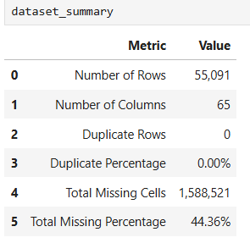

4.5 Preliminary Occupation Analysis
A preliminary screening was conducted to identify occupations with the highest number of job postings in the Job Bank dataset. The 20 most frequently posted job titles were initially identified as a broad labour-market screening step.
The results included occupations such as cooks, administrative assistants, software developers, and truck drivers. The occupations were subsequently filtered according to labour-market relevance, valid NOC classification, and compatibility with the O*NET and CIP mappings.
This process provided the basis for narrowing the analysis to approximately 15 occupations within the data, technology, and business analytics domain. These occupations were used in the subsequent labour-market, occupational, and recommendation analyses.
Table 5
Top 20 Occupations by Number of Job Postings
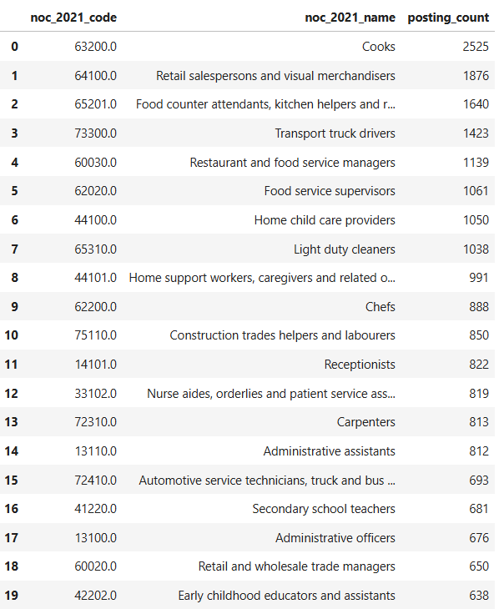
Figure 1
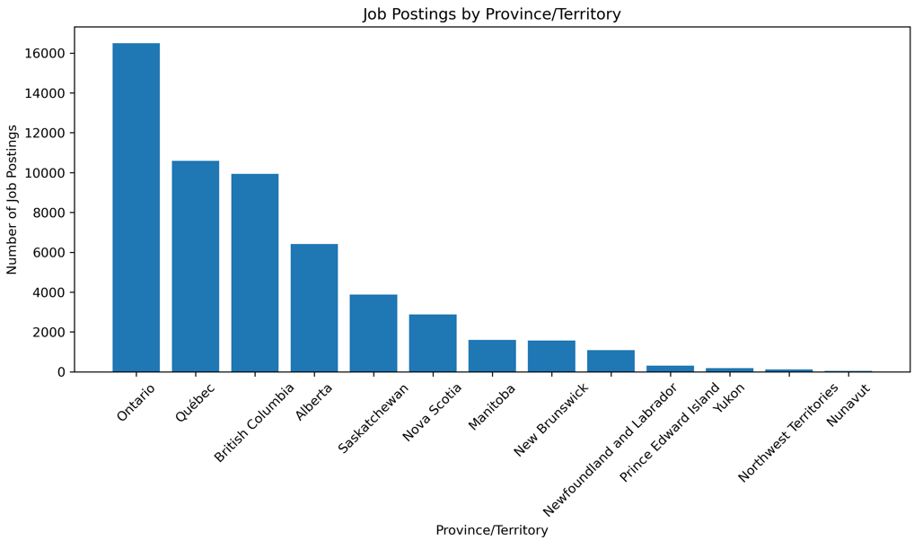
Job posting by province

Chapter 5 - Occupational Data Selection, Analysis, and O*NET & CIP Integration

5.1 Occupation Selection
Following the descriptive and diagnostic analysis of the Government of Canada Job Bank dataset, we have selected 15 occupations for detailed analysis. Selection was based on labour-market relevance, availability of Job Bank records, valid occupational classifications, and compatibility with the O*NET and CIP integration framework. The selected occupations represent the Canadian data, technology, business, and analytics domain targeted by the project.
The resulting dataset contained 5,629 job-posting records and 66 variables. Table 6 presents the distribution of job postings across the selected occupations. Food Service Supervisor (752), Administrative Assistant (583), and Continuing Care Assistant (545) having the highest posting counts, while Office Manager (101) had the lowest.

Table 6
Final occupations selected for the integrated occupational analysis and its dataset shape
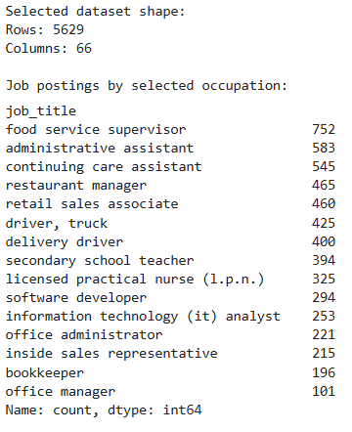
Figure 2
Distribution of Selected Occupations by Sector
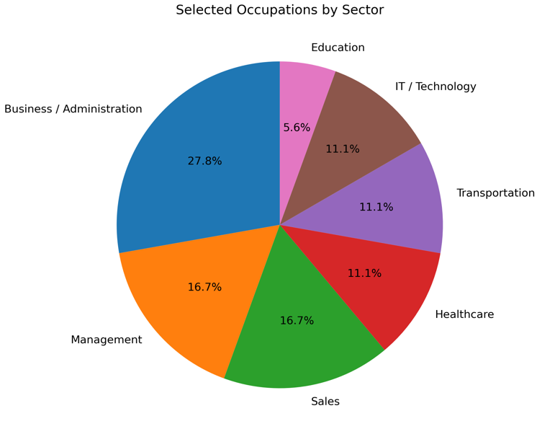

5.2 Regional Classification
We have grouped the selected Job Bank records for regional labour-market analysis into five regions: Prairies, Ontario, British Columbia, Atlantic, and Quebec. This classification was used to compare job-posting patterns across broader Canadian regions.

5.3 Diagnostic Labour-Market Analysis
The selected occupations were further analysed. In the analysis, posting counts, vacancy counts, geographic distribution, and salary information were used. This analysis helped to identify differences in labour-market demand across occupations and regions.
The Prairies recorded the highest number of job postings (1,890) which is followed by Ontario (1,387) and British Columbia (971). Average vacancies per posting were highest in British Columbia (1.48). This indicates that posting volume and vacancy size do not always follow the same pattern.
Figure 3
Distribution of Job Postings by Region
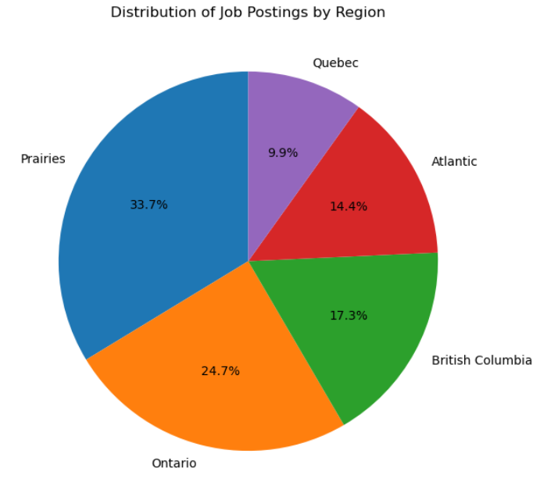

Figure 4
Comparison of labour-market demand across the selected occupations.
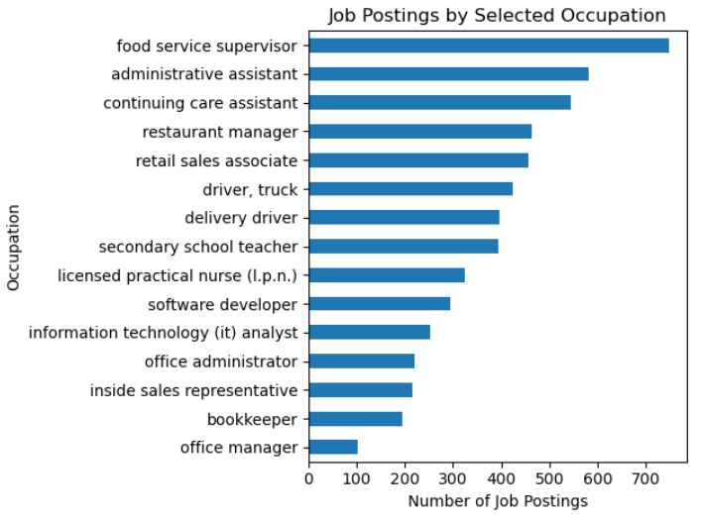
Table 7
Provincial and territorial distribution of selected occupational opportunities.
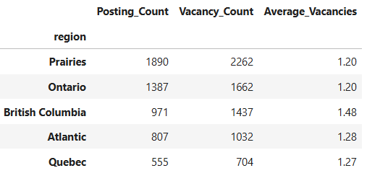
A provincial heatmap further showed that occupational demand varied across Canada. For example, continuing care assistants showed strong demand in Saskatchewan, while secondary school teachers showed high demand in Ontario.
Figure 5
Occupation demand across provinces
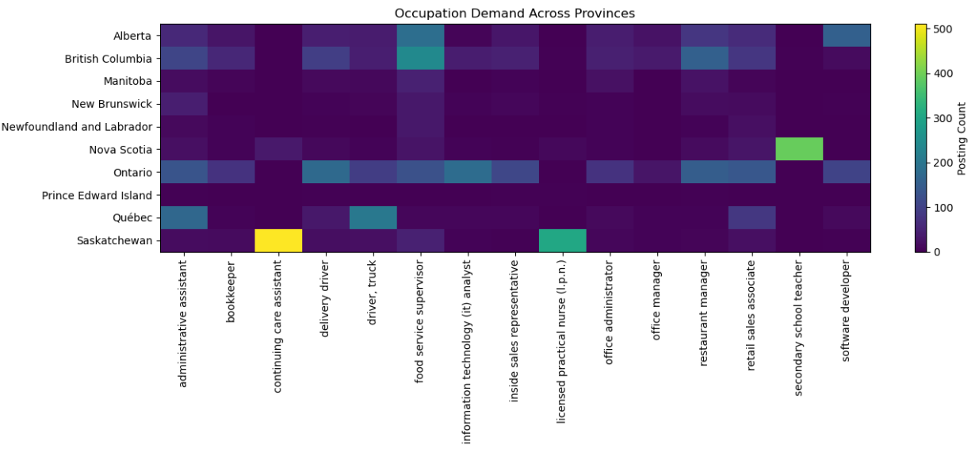
Salary distributions also differed across occupations. Software developers and IT analysts generally showed higher salary ranges. On the other hand, retail sales associates and delivery drivers were concentrated in lower salary bands.
Figure 6
Annual Salary Distribution Across Selected Occupations (CAD)
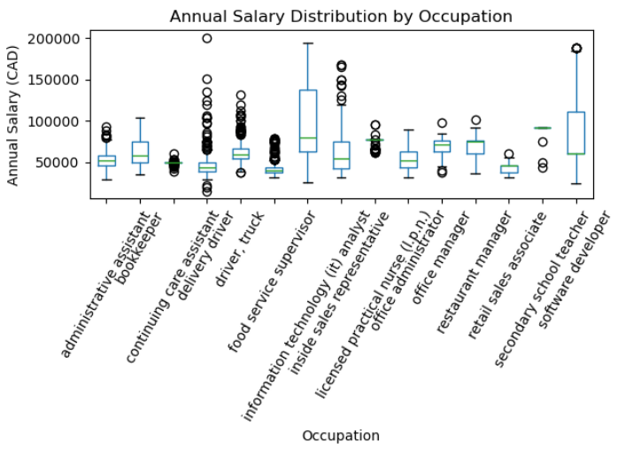

5.4 Education Requirements Analysis
Education requirements varied across the selected occupations. The analysis considered bachelor’s degrees, college/CEGEP credentials, trade qualifications, and secondary-school requirements.
Software Developer postings were mainly associated with bachelor’s-level education, while Food Service Supervisor, Delivery Driver, and Truck Driver showed stronger representation of secondary-school requirements. Restaurant Manager had a broader distribution across college and bachelor’s-level qualifications.
Figure 7
Distribution of Education Requirements Across Selected Occupations
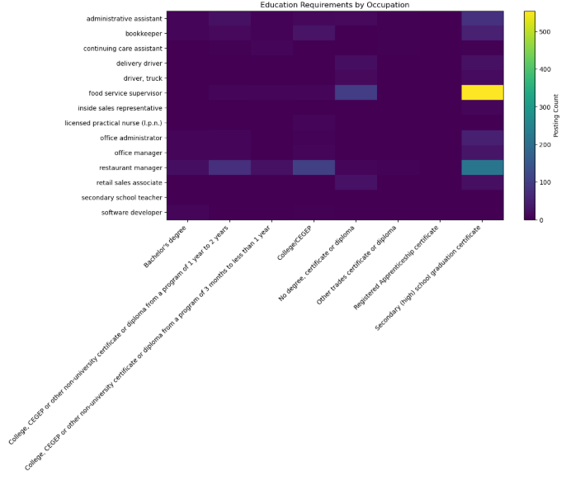
The heatmap shows clear differences in education requirements across occupations, with higher posting counts concentrated at different education levels. These patterns provide useful context for assessing candidate education alignment in the subsequent recommendation stages.

5.5 Experience and Employment Type Analysis
Experience requirements varied across the selected occupations. Many roles were concentrated around 1-2 years of experience, while occupations such as Restaurant Manager and Office Manager showed greater representation of longer experience requirements.
Figure 8
Distribution of Experience Requirements Across Selected Occupations
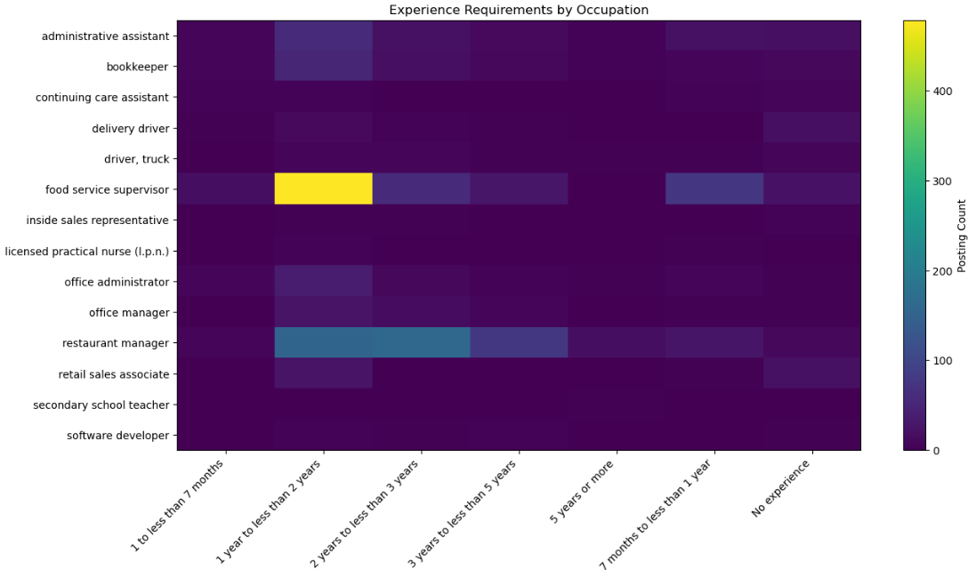
The results highlight differences in experience expectations across occupations and provide useful context for candidate–occupation suitability and skill-gap analysis.
Employment arrangements also varied across occupations. Full-time positions dominated most occupations, although part-time and part-time-to-full-time opportunities were also present. Food Service Supervisor had the highest overall posting volume in the selected dataset.
Figure 9
Employment Type Distribution Across Selected Occupations
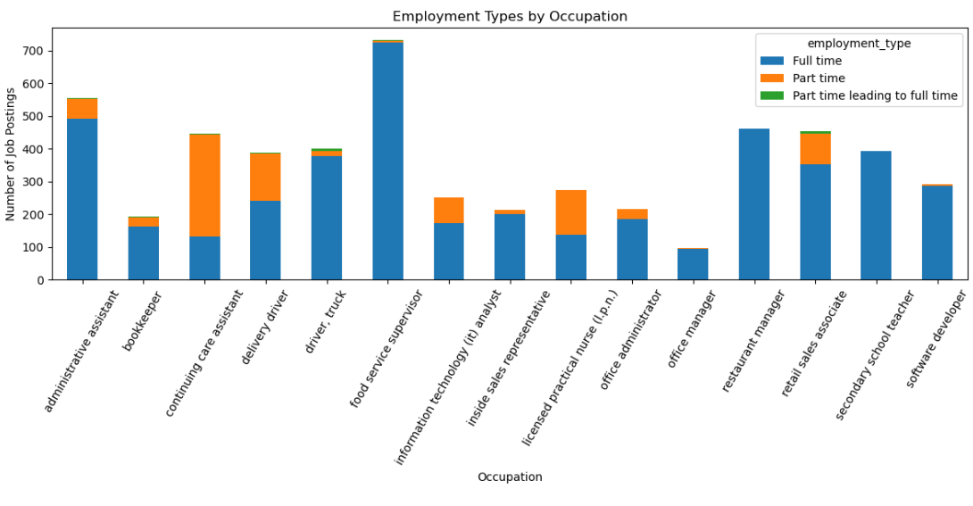
This analysis provides additional context on the structure and availability of employment opportunities across the selected occupations.

5.6 Demand Drivers
Occupational demand was assessed using posting count, total vacancies, and average vacancies per posting.
Table 8
Posting Count, Vacancy Count, and Average Vacancies per Posting by Occupation
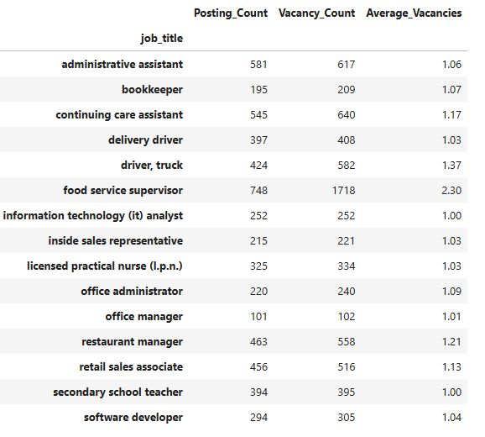
For most occupations, demand was mainly driven by posting volume, as average vacancies per posting were close to 1. Food Service Supervisor stood out with 2.30 vacancies per posting, indicating stronger demand from multiple vacancies within individual postings.

5.7 Experience and Salary Analysis
The relationship between experience requirements and annual salary was examined using mean salary across experience levels.
Table 9
Average Annual Salary by Experience Level
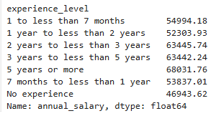
The results show an overall positive relationship. Average salary increased from CAD 46,943.62 for positions requiring no experience to CAD 68,031.76 for positions requiring five years or more of experience. Overall, positions with higher experience requirements tended to offer higher advertised salaries.

5.8 Salary and Vacancy Relationship
A correlation analysis examined the relationship between annual salary and vacancy count.
Table 10
Correlation Between Annual Salary and Vacancy Count
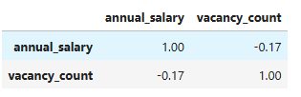
The correlation was -0.17, indicating a weak negative relationship. This suggests that higher advertised salaries were not associated with higher vacancy counts in the selected occupation sample.

5.9 Occupation and Education Association
A Chi-square test of independence was conducted to examine the relationship between occupation and education requirements.
Table 11
Chi-Square Test Results for Occupation and Education Association
Metric | Result
Chi-square statistic | 1,101.58
p-value | < 0.001
The result was statistically significant, indicating that education requirements differed across occupations.
A Kruskal-Wallis test was also conducted to examine salary differences across the selected occupations.
Table 12
Kruskal-Wallis Test Results for Salary Differences Across Occupations
Metric | Result
Kruskal-Wallis statistic | 3,502.75
p-value | < 0.001
The result was statistically significant, indicating that advertised salary distributions differed across occupations.

5.10 O*NET Occupational Integration
The selected occupations were mapped to corresponding ONET occupational profiles using the classification relationships established earlier. The mapping produced **20 occupation-to-ONET records**, representing 15 selected occupations and 18 unique O*NET occupations.
Some selected occupations were linked to multiple ONET profiles. For example, Continuing Care Assistant was mapped to Nursing Assistants and Orderlies, while Information Technology (IT) Analyst was linked to four ONET profiles.
Table 13
Selected occupations and their O*NET occupational mappings.
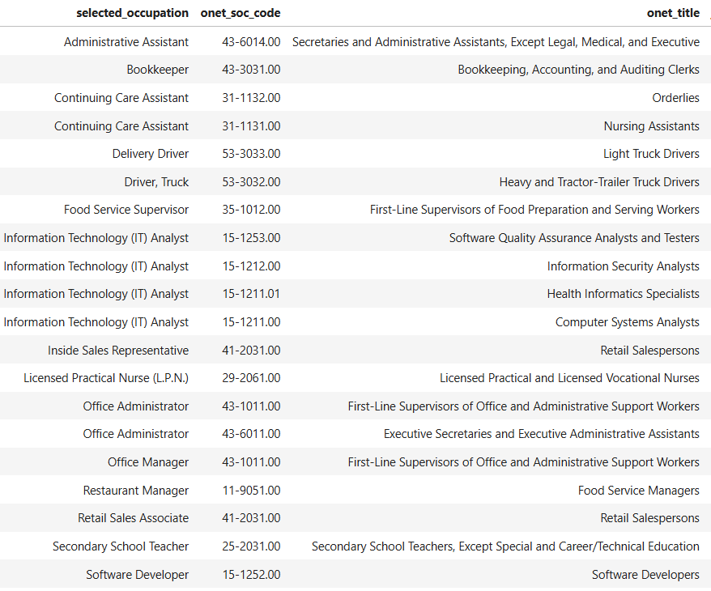
The selected ONET profiles were then enriched with skills, knowledge areas, abilities, tasks, education, training, and Job Zone information, using the ONET-SOC code as the common identifier. The resulting O*NET data form the occupational reference layer for subsequent candidate-to-occupation comparison and recommendation modelling.

5.11 O*NET Education, Training, and Job Zone Integration
ONET education data were integrated using the ONET-SOC codes. The dataset contained 300 education records, covering all 15 selected occupations and 18 unique O*NET occupations, with no missing occupation mappings.

Table 14
O*NET education-record coverage by selected occupation.
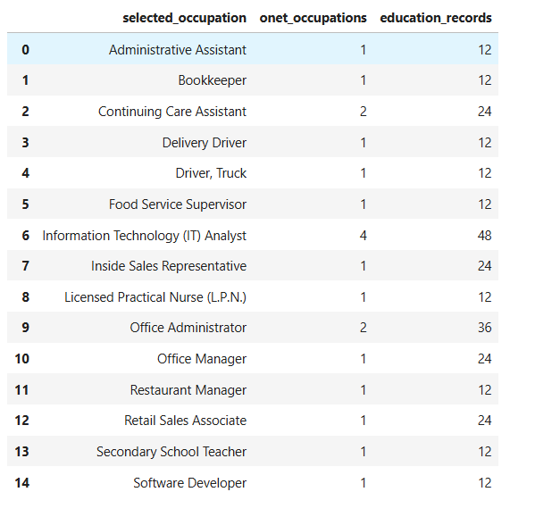
Training information was also incorporated into the occupational profiles. Most ONET occupations contained 29 training records, while shared ONET profiles produced higher counts.
Job Zone classifications ranged from 2 to 5 across the selected occupations. These education, training, and Job Zone attributes provide the occupational preparation information required for subsequent candidate qualification and skill-gap analysis.

5.12 CIP 2020 Educational Pathway Integration
CIP 2020 data were integrated with the selected O*NET occupations using the CIP 2020–SOC 2018 crosswalk. The CIP dataset contained 2,848 records; the crosswalk contained 6,097 records which represents 2,143 unique CIP codes and 868 unique SOC 2018 codes.
Matching the selected ONET occupations with the crosswalk produced 200 CIP–ONET mapping records, representing 156 unique CIP programs across all 15 selected occupations. All selected occupations had at least one mapped educational pathway.
Table 15
CIP educational pathway coverage by selected occupation.
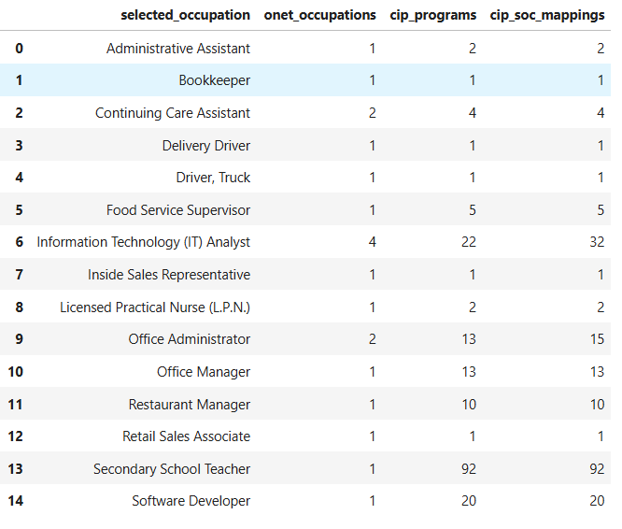
The number of educational pathways varied substantially across occupations. Secondary School Teacher had the highest coverage with 92 unique CIP programs, while several occupations had only one mapped program.
Some O*NET profiles were also shared by multiple selected occupations. These shared mappings were retained to preserve the original crosswalk relationships.
Overall, the CIP integration added an educational-pathway dimension to the occupational reference dataset for subsequent recommendation and skill-gap analysis.

5.13 Integrated O*NET and CIP Occupational Profile
The integrated occupational profile contains 20 records, representing 15 selected occupations and 18 unique O*NET occupations. It combines O*NET occupational attributes with education, training, Job Zone, and CIP pathway information.
Table 16
Final integrated O*NET and CIP occupational profile.
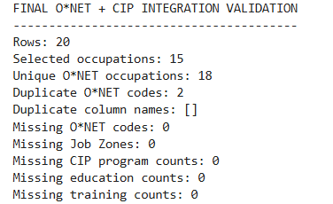
Validation confirmed no missing O*NET codes, Job Zones, education counts, or training counts. The two duplicate O*NET-SOC codes represent shared occupational mappings rather than errors.
The final dataset was saved as onet_cip_integrated_occupation_profile.csv and serves as the occupational reference layer for subsequent candidate and recommendation analysis.

Chapter 6 - Candidate Profiling, Baseline Occupation Recommendation, and Initial Model Analysis

6.1 Candidate Profiling
The available candidate data were transformed into structured profiles for occupation matching. 65 candidate profiles were processed, with 63 valid candidates retained for analysis.
Each candidate was evaluated against the selected occupation set. The analysis generated a recommendation score, recommendation percentage, and occupation rank, where Rank 1 represents the strongest match.
Table 17
Candidate Profiling and Recommendation Validation
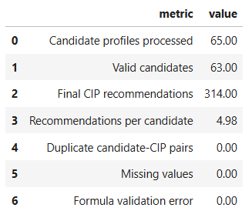
The validation produced 314 candidate-CIP recommendations, with approximately 5 recommendations per candidate. No duplicate pairs, missing values, or formula validation errors were identified.

6.2 Baseline Occupation Recommendation
The baseline model ranked occupations for each candidate based on the calculated recommendation score, with Rank 1 representing the highest suitability.
The results showed considerable variation across candidates. For example, Candidate_006 received a score of 90.36% for Software Developer, while Candidate_009 received 25.65% for Administrative Assistant.
Table 18
Top-Ranked Occupation Recommendations for Selected Candidates
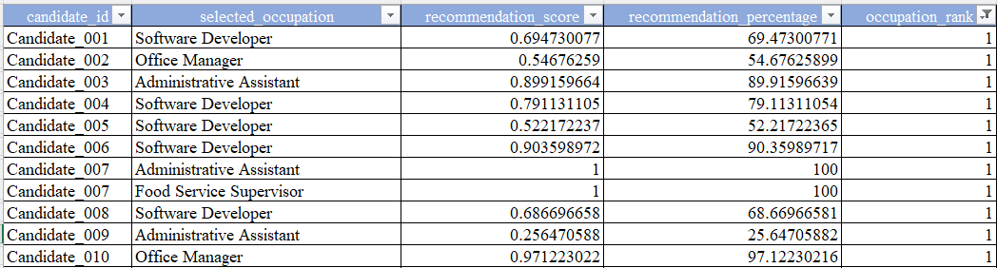
The Rank 1 results frequently included Software Developer, Office Manager, Administrative Assistant, IT Analyst, and Bookkeeper. The baseline ranking provides a reference point for evaluating the more advanced recommendation models presented in the following sections.

6.3 Score Distribution and Recommendation Behaviour
The recommendation scores showed variation in occupational alignment across candidates. For example, Candidate_001 received 69.47% for Software Developer, while Candidate_006 received 90.36% for the same occupation.
Seven candidates received a 100% score for both Administrative Assistant and Food Service Supervisor, resulting in both occupations being ranked first.
Table 19
Candidates with Multiple Rank 1 Recommendations
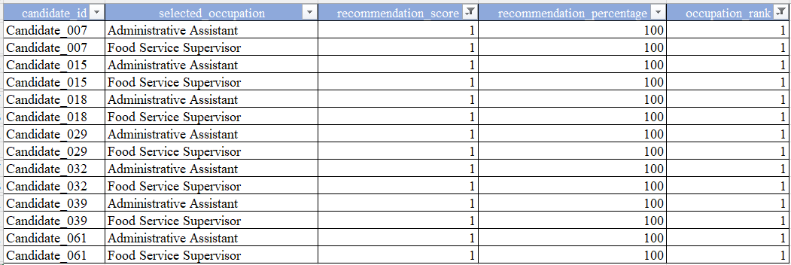
This pattern indicates strong alignment but also suggests that the baseline scoring method may not always distinguish clearly between occupations. Further model refinement is therefore required.

6.4 Data-Quality and Model Behaviour Observations
The validation results showed no duplicate candidate-CIP pairs, missing values, or formula errors which indicates that the recommendation dataset was structurally consistent.
The analysis also showed identical scores for Inside Sales Representative and Retail Sales Associate across several candidates, suggesting limited differentiation between these closely related occupations.
Table 20
Examples of Identical Recommendation Scores
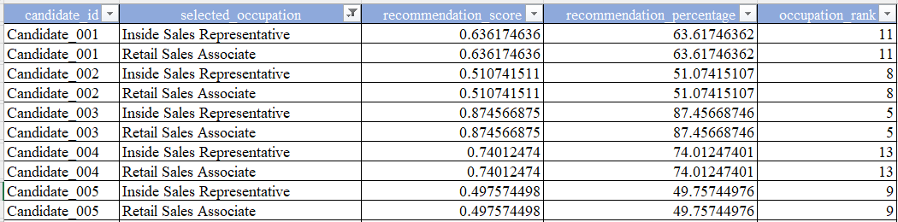
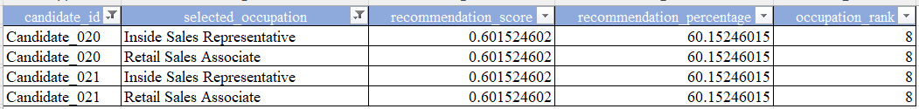
Additionally, Candidate_020 and Candidate_021 produced identical scores across occupations, suggesting highly similar candidate profiles. These observations are considered during subsequent model development and refinement.

6.5 Baseline Evaluation
The baseline successfully processed 65 candidate profiles, including 63 valid candidates and 314 final CIP recommendations, with no missing values, duplicate candidate-CIP pairs, or formula errors.
The results showed meaningful score variation but also some identical and perfect scores, highlighting areas for model refinement.
Overall, the baseline provides a reference point for evaluating subsequent recommendation, skill-gap, and RAG components.

Chapter 7 - Multi-Factor Recommendation Engine Development and Model Evaluation

7.1 Multi-Factor Recommendation Engine
The recommendation engine extended the baseline model by incorporating keyword matching, TF-IDF textual similarity, Sentence-Transformer semantic similarity, Canadian labour-market demand, and CIP-based education alignment.
The system evaluated 63 valid candidates across 15 occupations, producing 945 candidate–occupation pairs.
The final hybrid model used:
- 35% skill-based match
- 35% semantic similarity
- 20% Canadian labour-market demand
- 10% CIP-based education alignment
Validation confirmed no duplicate pairs or missing scores, with all scores within the 0-1 range. All 63 candidates received a Top-1 recommendation.

7.2 Keyword and TF-IDF Recommendation Models
A keyword-based recommendation model was first established as a transparent textual baseline. It compared candidate profile information with occupation-related keywords to generate occupation-level recommendation scores and rankings. The results showed limited differentiation when exact keyword matches were absent.
TF-IDF similarity was then introduced to provide a more informative text-based representation by giving greater weight to distinctive terms. This produced more differentiated candidate–occupation similarity scores and rankings.
For example, Candidate_001 received the highest TF-IDF score for Information Technology (IT) Analyst, with a normalized score of 1.00 (100%), followed by Administrative Assistant at 41.64%.
Table 21
TF-IDF-Based Occupation Recommendation Results for Candidate_001
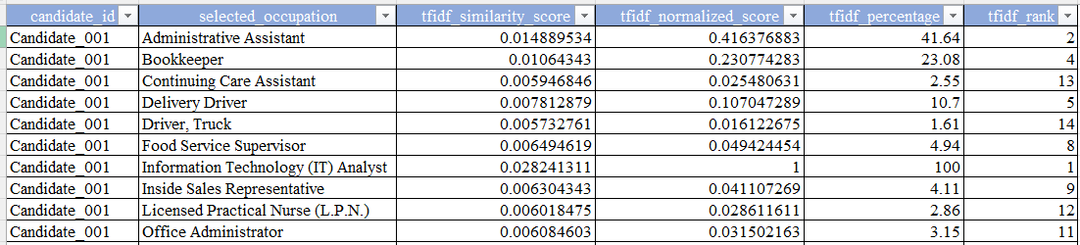
These results established the keyword and TF-IDF approaches as progressive textual baselines before applying the Sentence-Transformer semantic model.

7.3 Sentence-Transformer Semantic Recommendation
The recommendation engine incorporated Sentence-Transformer embeddings to capture semantic similarity between candidate profiles and occupation descriptions. This helped address limitations of keyword-based approaches by identifying similar skills and responsibilities expressed using different terminology.
For Candidate_001, the semantic model ranked Information Technology (IT) Analyst highest with a normalized score of 73.10%, followed by Administrative Assistant at 71.07%.
The semantic scores were subsequently combined with the skill-based scores as part of the final hybrid recommendation model, reducing reliance on a single matching approach.
Table 22
Sentence-Transformer Semantic Recommendation Results for Candidate_001
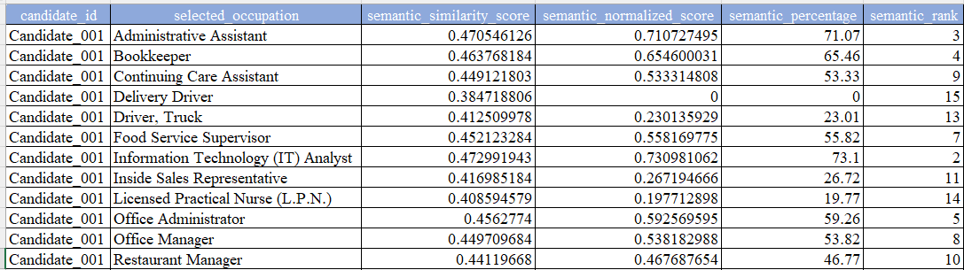

7.4 Labour-Market Demand and Education Alignment
Two additional factors were incorporated to improve recommendation relevance: Canadian labour-market demand and CIP-based education alignment.
The labour-demand score incorporated Canadian employment demand, while the education-alignment score considered the relationship between a candidate's education and the recommended occupation.
Both factors were evaluated through Demand-Adjusted and Education-Adjusted recommendation variants and were retained as components of the final hybrid recommendation framework.

7.5 Final Hybrid Recommendation Model
The final recommendation score combined the four major dimensions:
Final Hybrid Score = 35% Skill Match + 35% Semantic Similarity + 20% Canadian Labour Demand + 10% CIP Education Alignment
Skill and semantic similarity contributed 70% of the score, while Canadian labour demand and education alignment contributed 20% and 10%, respectively. This weighting kept recommendations primarily candidate-specific while incorporating labour-market and educational relevance.
The final model generated 945 candidate–occupation comparisons for 63 valid candidates across 15 occupations, producing 63 Top-1 and 315 Top-5 recommendations.
Table 23
Baseline versus Final Hybrid Recommendation Results
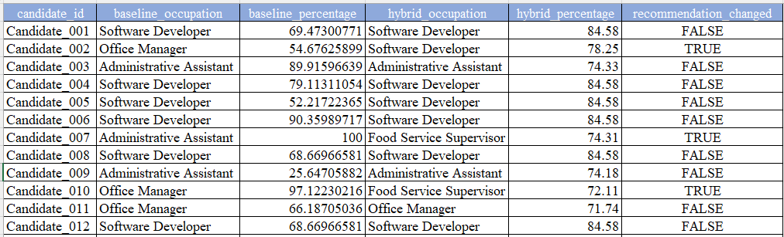
The comparison shows that the hybrid model changed some Top-1 recommendations while retaining others, demonstrating the effect of incorporating semantic, labour-market, and education factors into the baseline ranking.

7.6 Model Comparison and Recommendation Transition
The recommendation approaches were compared to assess how the additional semantic, labour-market, and education factors affected occupational rankings.
Of the 63 valid candidates, 24 changed their Top-1 occupation, representing a 38.1% Top-1 transition rate.
Table 24
Top-1 Recommendation Transitions from Baseline to Hybrid Model
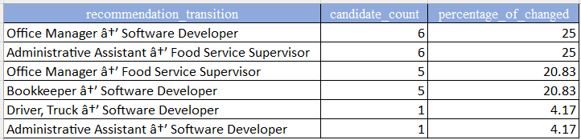
The transitions show that the multi-factor model produced meaningful changes rather than simply reproducing the baseline recommendations.
Because the project does not contain a labelled ground-truth occupation for each candidate, these transitions indicate model behaviour and refinement, not predictive accuracy.

7.7 Recommendation Review and Error Diagnostics
The diagnostic analysis identified 512 potential recommendation-review cases requiring further inspection. These were treated as potential review cases rather than confirmed model errors, since no ground-truth occupation labels were available.
week6_error_analysis.csv shows the detailed analysis of these potential review cases, including unusual score patterns, occupation transitions, and differences between recommendation factors. This diagnostic process supports further refinement and quality review of the recommendation engine.

7.8 Validation and Exported Recommendation Outputs
The keyword, TF-IDF, semantic, labour-market, education, and hybrid recommendation pipeline completed its technical validation successfully, with 100% of the defined validation checks passed. The final dataset contained 63 valid candidates, 15 occupations, and 945 candidate–occupation pairs, with no duplicate pairs or missing final scores.
The pipeline generated 13 structured CSV deliverables containing intermediate and final recommendation results for subsequent analysis and system integration.

Figure 10
Final validation output.
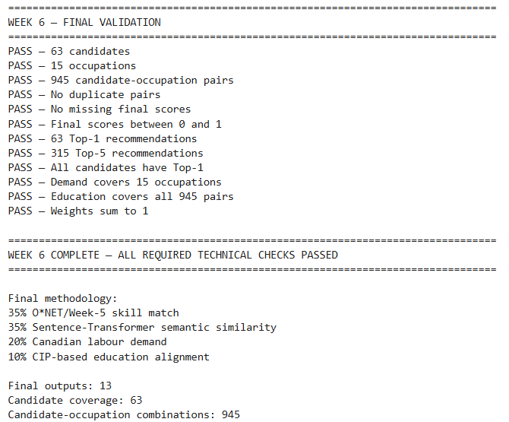
The validation confirmed candidate and occupation coverage, score validity, Top-1 and Top-5 recommendation generation, demand and education coverage, and correct hybrid-model weighting.
The exported outputs provide the data foundation for subsequent skill-gap analysis, recommendation explanation, and RAG-based career guidance.

7.9 Summary of Week 6 Model Results
The recommendation engine progressed from keyword and TF-IDF text matching to Sentence-Transformer semantic similarity, followed by Canadian labour-demand and CIP education alignment, culminating in the final multi-factor hybrid model.
The final model evaluated 63 candidates across 15 occupations, producing 945 candidate-occupation comparisons, 63 Top-1 recommendations, and 315 Top-5 recommendations. 24 candidates (38.1%) changed their Top-1 recommendation from the baseline, while 512 potential recommendation-review cases were identified.
Overall, the model provides a structured foundation for the subsequent skill-gap analysis, recommendation explanation, and RAG-based career-advisory components.
Table 25
The principal results are summarized below.
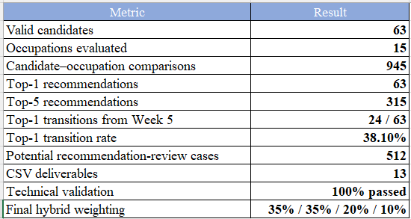

Chapter 8 - RAG-Based Career Advisory System Development and Integration

8.1 Introduction
The Retrieval-Augmented Generation (RAG) component was developed as the evidence-grounded advisory layer of the proposed AI-powered Career Advisor. Its primary purpose is to transform the outputs of the occupation-ranking and skill-gap analysis modules into personalized, explainable, and evidence-supported career advice.
Rather than relying solely on the internal knowledge of a Large Language Model (LLM), the RAG system retrieves relevant information from a project-specific knowledge base and uses this evidence to construct career explanations. This approach improves transparency and traceability by connecting advisory statements to identifiable source information.
The RAG component does not independently determine the candidate's career recommendation. The occupation recommendation is produced by the previously developed hybrid ranking model, while RAG retrieves supporting evidence and generates a structured explanation of the recommendation.

8.2 RAG System Architecture
The RAG-based career advisory pipeline consists of the following major stages:
Source Data → Knowledge Base → Document Standardization → Semantic Embedding → FAISS Index → Evidence Retrieval → Candidate Evidence Package → Grounded Career Explanation
The RAG component was integrated with the existing candidate profiling, occupation ranking, prescriptive skill-gap analysis, labour-market analysis, and education-alignment modules.
The complete advisory workflow can therefore be represented as:
Candidate CV → Skill Extraction → Candidate Profile → Occupation Ranking → Skill-Gap Analysis → Skill Prioritization → Labour/Education Integration → RAG Retrieval → Career Advisory Explanation
This architecture separates recommendation from explanation while allowing both components to operate as part of one integrated career advisory system.

8.3 Development of the RAG Knowledge Base
A project-specific knowledge base was constructed using six complementary information sources:
- O*NET occupation profiles
- O*NET skill information
- O*NET occupational tasks
- Canadian labour-market demand information
- CIP-based education pathways
- Integrated occupation profiles
These sources were selected to provide complementary evidence about occupational requirements, candidate skill gaps, labour-market conditions, and potential education pathways.
The knowledge-base construction process produced 707 unique retrieval documents covering 15 target occupations.
Table 26
Overall RAG-Based Career Advisory Architecture
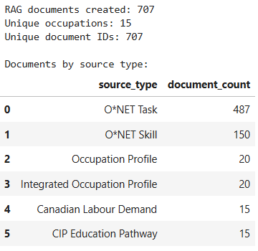
Each document was assigned a unique identifier and associated metadata such as occupation and source type. This structure enabled the retrieval results to remain traceable to their original evidence source.

8.4 Semantic Embedding and Vector Index
To enable semantic retrieval, the knowledge-base documents were converted into vector representations using the sentence-transformers/all-MiniLM-L6-v2 embedding model.
The resulting embedding matrix contained 707 vectors with 384 dimensions each. The embeddings were normalized and validated for invalid numerical values and zero vectors.
The embeddings were indexed using FAISS IndexFlatIP, which enabled efficient similarity-based retrieval using inner-product similarity. Index integrity was verified through self-retrieval testing. The indexed documents successfully retrieved their corresponding documents as the highest-ranked results with a similarity score of approximately 1.0. This test confirmed correct indexing and document-vector alignment. However, it was treated only as an index integrity test, not as evidence of end-to-end RAG retrieval performance.
Figure 11
Semantic Embedding and FAISS Configuration
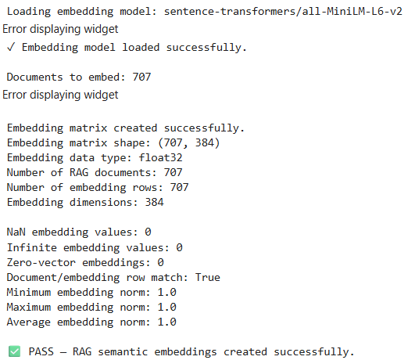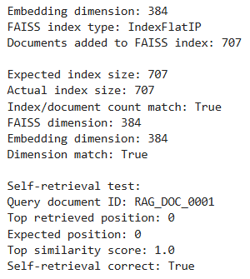

8.5 Semantic Evidence Retrieval
A reusable semantic retrieval function was developed to connect advisory queries with the project knowledge base.
The retrieval process consists of:
- converting the query into an embedding;
- searching the FAISS index;
- ranking documents according to semantic similarity;
- applying metadata-based filtering where appropriate; and
- returning the relevant evidence and associated source metadata.
The retrieval mechanism was tested using queries related to O*NET skills, Canadian labour-market demand, and education pathways. These tests confirmed that the retrieval layer could return evidence from the required source categories.
The retrieval system was subsequently extended to support exact evidence retrieval for identified skill gaps. This was important because generic occupational information alone may not adequately support a statement about a specific missing skill.

8.6 Candidate-Specific Evidence and Grounded Explanations
The RAG system receives the outputs of the recommendation and prescriptive analytics modules and creates a candidate-specific evidence package.
The package may include:
- recommended occupation;
- hybrid recommendation score;
- identified skill gaps;
- prioritized skills;
- occupational tasks;
- Canadian labour-market evidence;
- CIP education information; and
- supporting source identifiers.
The system then uses this information to construct a structured career explanation.
The explanation connects the recommendation with supporting evidence rather than simply providing a generic description of the occupation. For example, when a candidate is recommended for a particular occupation, the explanation can identify the relevant skill gaps, explain why those skills matter for the occupation, provide occupational task evidence, and incorporate labour-market or education information where available.
Table 27
Example Candidate RAG Evidence Package
Evidence Component | Example Output
Candidate | Candidate_001
Recommended occupation | Software Developer
Hybrid score | 84.58%
Priority skill gaps | Active Listening, Monitoring, Speaking
O*NET evidence | RAG document IDs
Task evidence | Occupational task documents
Labour-market evidence | Canadian demand document
Education evidence | CIP pathway document

8.7 Evidence Traceability and Responsible Generation
Evidence traceability was a central design principle of the RAG implementation. Each retrieved document contains a unique source identifier, allowing evidence used in an explanation to be traced back to its knowledge-base record.
The resulting relationship can be represented as:
Recommendation → Analytical Evidence → Retrieved Evidence → Source Document
This structure supports transparency and makes it possible for a reviewer to inspect the evidence supporting a generated explanation.
The system also recognizes several limitations of evidence-based generation. In particular, the absence of a skill from a candidate's CV does not necessarily prove that the candidate lacks that skill. Similarly, the absence of a CIP mapping does not necessarily mean that no education pathway exists. These distinctions were preserved in the advisory logic to reduce overinterpretation of incomplete evidence.

8.8 Integration with the Career Recommendation System
The RAG component was integrated with the full candidate recommendation pipeline.
The Week 6 recommendation system produced 945 candidate–occupation combinations for 63 candidates across 15 occupations. The RAG component uses the resulting Top-1 occupation and associated analytical information to generate candidate-specific explanations.
The integrated system generated 63 personalized RAG explanations:
- 56 candidates had identified skill gaps;
- 7 candidates had no identified missing skills across the evaluated occupations.
All 63 candidate explanations were subjected to automated structural validation. The validation confirmed that the explanations were aligned with the candidate's Week 6 Top-1 recommendation and that the referenced evidence identifiers were valid.
Figure 12
Candidate-Level RAG Output Summary
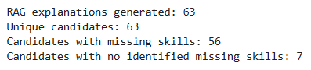
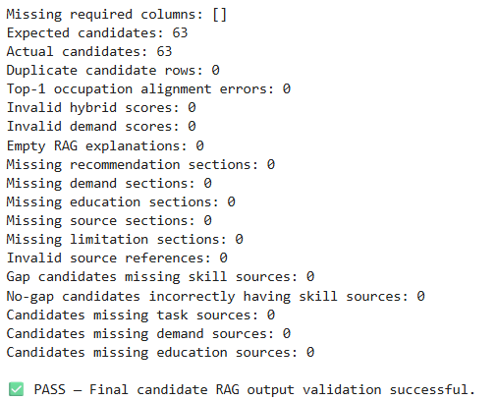

8.9 Human Evaluation Framework
Automated validation can confirm structural consistency but cannot determine whether an explanation is genuinely useful, correct, clear, or sufficiently grounded. Therefore, a human evaluation framework was developed for the RAG component.
A 20-candidate human-evaluation sample was prepared for manual review. Each explanation is evaluated using seven quality dimensions:
- Relevance
- Correctness
- Groundedness
- Citation correctness
- Completeness
- Clarity
- Usefulness
Each criterion is rated on a 1–5 scale. Reviewers also record the number of unsupported claims and provide qualitative notes.
The overall RAG quality score is calculated as the unweighted mean of the seven quality dimensions.
Figure 13
RAG Human Evaluation Criteria
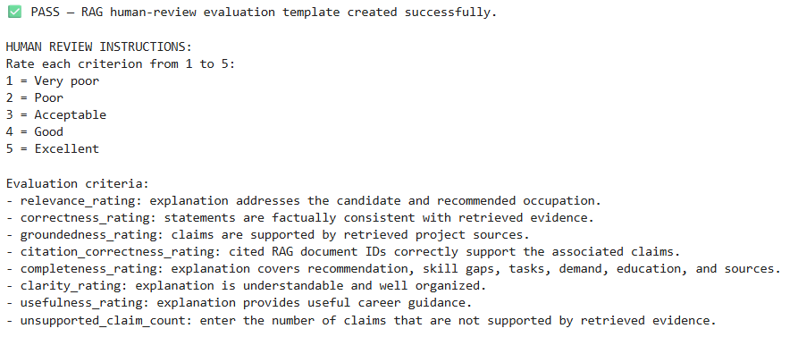
At the implementation stage, the human-review fields remained incomplete. Therefore, final RAG quality metrics were intentionally not calculated until the manual evaluation is completed.

8.10 RAG Error Analysis
A formal error-analysis framework was integrated into the system to identify potential weaknesses in generated career explanations.
The RAG-specific error categories include:
- low overall explanation quality;
- low groundedness;
- low citation correctness; and
- unsupported claims.
These predefined error categories will allow problematic explanations to be identified after completion of the human evaluation.
The error-analysis framework is connected to the wider Week 7 evaluation framework, which also evaluates skill extraction, occupation recommendation ranking, and skill-gap identification.

8.11 Development Outcome
The RAG development successfully established an evidence-grounded advisory layer within the career recommendation system.
The principal outcomes were:
- creation of a 707-document RAG knowledge base;
- integration of six evidence sources;
- generation of 384-dimensional semantic embeddings;
- development of a FAISS vector-search index;
- implementation of semantic evidence retrieval;
- exact evidence retrieval for candidate-specific skill gaps;
- generation of 63 personalized career explanations;
- automated validation of all candidate RAG outputs; and
- establishment of a structured human evaluation and error-analysis framework.
The resulting system is therefore more than a generic conversational chatbot. It combines analytical recommendation outputs with retrieved occupational, labour-market, skill, and education evidence to produce traceable career advisory explanations.

Chapter 9 - Deployment And Final System Analysis

9.1 Introduction
This chapter presents the deployment and final analysis of the AI-Powered Career Advisor system. The Week 8 stage integrated the recommendation, skill-gap, and RAG components into deployment-ready datasets and performed final integrity and reproducibility checks.
The final system covers 63 candidates, 15 occupations, and 945 candidate-occupation evaluations. At the Week 8 deployment-integration stage, human evaluation was still pending; the completed human evaluation is presented in Chapter 10.

9.2 Deployment Architecture and Integration
The deployment stage consolidated the outputs produced during Weeks 6 and 7 into a unified candidate-level representation. The final deployment architecture consists of four principal layers:
- Recommendation Layer - hybrid content-based ranking of 15 occupations for each candidate.
- Prescriptive Layer - identification and prioritization of skill gaps for the candidate's final Top-1 occupation.
- Explainability Layer - source-grounded RAG explanations aligned with the final Top-1 recommendation.
- Deployment Layer - structured CSV datasets prepared for integration into a Streamlit application.
The final candidate deployment master contains 63 candidate profiles and 19 integrated fields, combining recommendation scores, component scores, skill-gap information, development actions, RAG explanations, and deployment status.

9.3 Top-5 Career Recommendation Integration
For each candidate, the final hybrid recommendation model evaluated 15 occupations and produced a ranked list of career options. The deployment layer retained the five highest-ranked occupations for presentation to the user.
The resulting Streamlit-ready dataset contains 315 recommendation records, corresponding to five recommendations for each of the 63 candidates. Each recommendation includes the occupation, ranking position, overall hybrid score, and the underlying skill, semantic, labour-demand, and education-alignment components.
Validation confirmed that every candidate received exactly five recommendations and that ranking positions were consistently represented from Rank 1 through Rank 5.
Figure 14
Streamlit Top-5 Recommendation Output
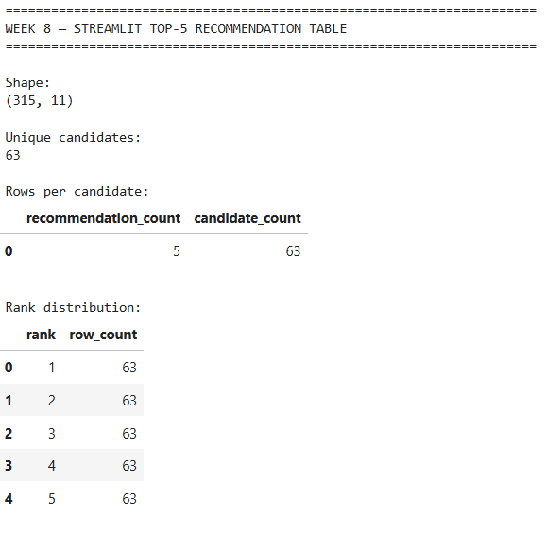
The distribution of final Top-1 recommendations shows that the model assigned candidates primarily to four occupations. Software Developer was the most frequently selected Top-1 occupation, with 35 of 63 candidates (55.56%), followed by Administrative Assistant, Food Service Supervisor, and Office Manager.

9.4 Prescriptive Skill-Gap Integration
The prescriptive layer was aligned with each candidate's actual final Top-1 occupation. This alignment was necessary to ensure that the recommended skill-development actions addressed the occupation ultimately presented as the primary career recommendation.
The final analysis identified 56 candidates with one or more priority skill gaps, while 7 candidates had no priority skill gaps identified. Across all candidates, the average number of identified missing skills was 2.76.
The corrected Top-1 skill-gap pipeline confirmed that the occupation associated with each skill-gap recommendation matched the candidate's final Top-1 occupation for all candidates receiving skill-gap recommendations.
Figure 15
Top-1 Prescriptive Skill-Gap Summary
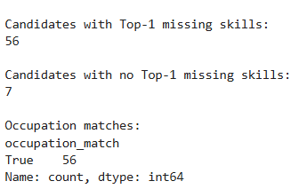
The prescriptive layer therefore provides a practical transition from career recommendation to career development by identifying specific skills that candidates may need to strengthen for their recommended occupation.

9.5 RAG Explanation Integration and Alignment
The final deployment stage included a validation of the alignment between RAG explanations and the final Top-1 career recommendations. Initial validation identified 16 of 63 candidate explanations (25.4%) whose occupation differed from the final hybrid Top-1 recommendation.
These mismatched explanations were withheld from deployment and regenerated using occupation-specific evidence packages. Following regeneration, all 16/16 explanations were aligned with the final Top-1 occupation.
The final RAG deployment dataset therefore contains 63 candidate-level explanations, comprising 47 original aligned explanations and 16 regenerated explanations.
Figure 16
Final RAG Deployment Output and Alignment Status
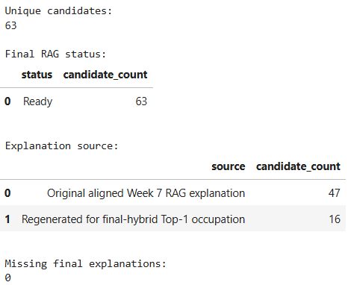
The final deployment process achieved complete RAG coverage, with 63/63 candidates having a Top-1-aligned explanation.
It should be noted that the regenerated explanations were constructed using source-grounded evidence and traceable source metadata. Unless an actual generative model is applied to the retrieved document text, these outputs should be described as source-grounded and evidence-traceable explanations, rather than independently generated LLM responses.

9.6 Final Project KPIs
The final project KPI analysis provides a consolidated view of system scale and deployment coverage.
The system processed 63 candidates across 15 occupations, resulting in 945 candidate–occupation evaluations. The average Top-1 hybrid recommendation score was 78.18%, while the average Top-1 skill-alignment component was 96.06% and the average semantic-similarity component was 77.57%.
The average labour-demand component was 37.06%. These values represent model scoring components and should not be interpreted as prediction accuracy.
The system identified an average of 2.76 missing skills per candidate, with 56 candidates receiving skill-development recommendations.
Table 28
Final Project KPI Summary
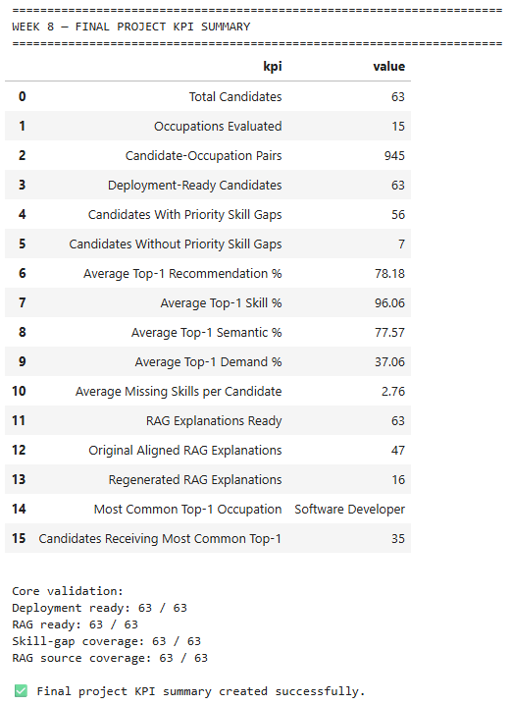
The deployment validation further confirmed complete coverage of the final candidate outputs: 63/63 candidates had deployment-ready profiles and 63/63 had final RAG explanations.

9.7 Final Business and Research Insights
The final analysis produced several descriptive findings relevant to the proposed career advisory system.
First, the recommendation distribution was concentrated among four occupations, with Software Developer representing 55.56% of all Top-1 recommendations. Second, Software Developer also had the highest average Top-1 hybrid recommendation score among the occupations receiving final Top-1 recommendations.
The prescriptive analysis showed that 56 of 63 candidates had at least one priority skill gap, indicating that career recommendation and skill-development guidance can be presented together as complementary outputs.
Labour-demand analysis showed that Food Service Supervisor had the highest average demand component among the final Top-1 occupations. Skill-gap burden varied across occupations, demonstrating differences between recommendation alignment and the amount of additional skill development identified.
Table 29
Final Business and Research Insights
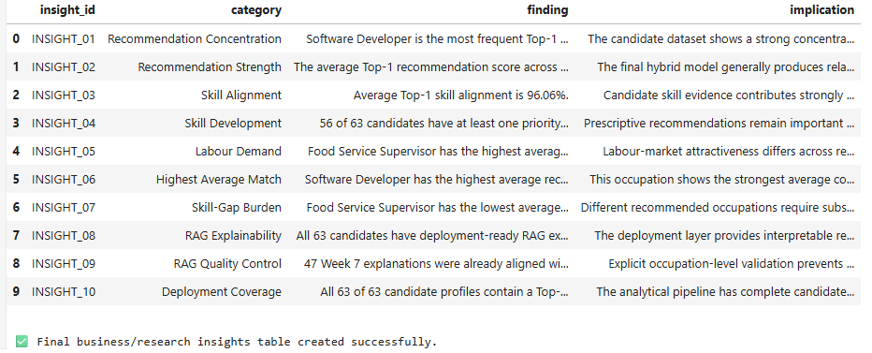
These findings are descriptive characteristics of the model outputs rather than evidence of predictive accuracy or real-world career success. Formal human evaluation is required before such conclusions can be interpreted as evidence of recommendation effectiveness.

9.8 Deployment Artifacts
The final deployment stage produced nine CSV deliverables covering candidate-level outputs, recommendation results, RAG explanations, analytical summaries, configuration information, and validation records.
The principal deployment artifacts include:
- Candidate Deployment Master
- Streamlit Top-5 Recommendations
- Final Deployment RAG
- Occupation Deployment Summary
- Project KPI Summary & Final Project Insights
- Deployment Artifact Register & Deployment Configuration
- Integrity Validation
Table 30
Week 8 Deployment Artifact Register
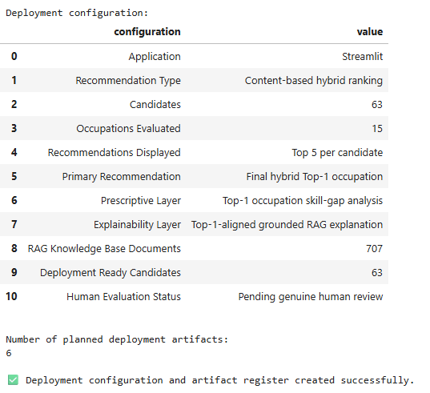
The deployment configuration documents Streamlit as the intended application environment, the content-based hybrid ranking approach, the prescriptive skill-gap layer, the grounded RAG explanation layer, and the current human-evaluation status.

9.9 Reproducibility and Integrity Validation
A final reproducibility and integrity audit was performed before completion of the deployment stage. The audit consisted of 12 validation checks, covering candidate coverage, candidate–occupation pair coverage, occupation coverage, Top-5 coverage, Top-1 alignment, RAG coverage, deployment readiness, skill-gap coverage, RAG knowledge-base integrity, source reconciliation, and human-evaluation documentation. All 12/12 checks passed, with zero failed checks.
The exported files were subsequently reloaded from disk and independently checked. The read-back validation consisted of 11 structural checks, all of which passed.
The read-back process confirmed that the exported datasets retained their expected row counts and candidate coverage. It also confirmed exactly five recommendations per candidate, complete RAG coverage, deployment readiness, and preservation of the successful integrity audit.
Figure 17
Exported-File Read-Back Validation
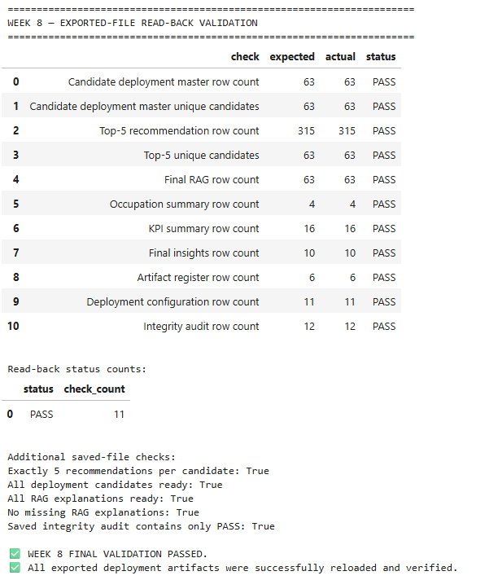
These checks provide evidence that the final deployment artifacts were successfully generated, saved, reloaded, and structurally verified. They do not constitute a measure of recommendation accuracy or model effectiveness.

9.10 Deployment Outcome
The Week 8 deployment stage successfully transformed the outputs of the analytical pipeline into structured, deployment-ready datasets.
The final system provides:
- 63 complete candidate deployment profiles
- 315 Top-5 career recommendations
- 56 candidates with priority skill-gap recommendations
- 7 candidates without priority skill gaps
- 707 RAG knowledge-base documents
- 63 Top-1-aligned RAG explanations
- 9 exported Week 8 deliverables
- 12/12 final integrity checks passed
- 11/11 exported-file read-back checks passed
The deployment preparation therefore achieved complete structural coverage across the intended system components.
However, the current results should be interpreted as implementation, integration, and deployment validation. Human evaluation remains necessary to determine recommendation relevance, skill-extraction performance, skill-gap accuracy, ranking quality, and RAG response quality.
Chapter 10 - Human Evaluation and Final Validation

10.1 Human Evaluation Dataset and Completeness
The final human evaluation covered four major components of the AI-Powered Career Advisor: skill extraction, career recommendation ranking, skill-gap identification, and RAG-generated advisory outputs. The evaluation included 200 skill-extraction records, 300 recommendation-ranking records, 200 skill-gap records, and 20 RAG evaluations.
Figure 18
Human Evaluation Dataset and Completeness Validation
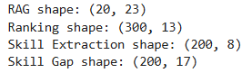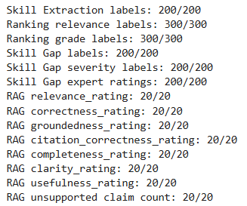
All required human labels and ratings were complete, providing a finalized basis for calculating the evaluation metrics.

10.2 Skill Extraction and Skill-Gap Evaluation
The skill extraction component achieved 83.50% accuracy, 88.11% precision, 88.73% recall, and 88.42% F1-score across 200 manually labeled records.
The skill-gap identification component achieved 83.50% accuracy, 64.91% precision, 74.00% recall, and 69.16% F1-score. The average expert rating for the identified skill gaps was 4.84/5, with 96.00% of expert ratings receiving a score of 4 or 5.
Figure 19
Skill Extraction and Skill-Gap Evaluation Results

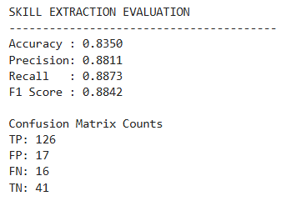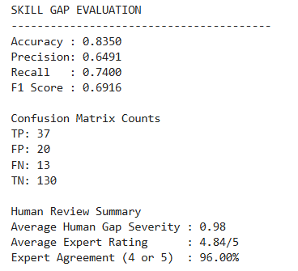
These results show stronger performance for general skill extraction than for identifying specific skill gaps, indicating that skill-gap identification remains a comparatively more challenging component of the system.

10.3 Career Recommendation Ranking Evaluation
Human evaluation of the Top-5 career recommendations across 20 candidates produced a mean Precision@5 of 88.00%, Recall@5 of 69.15%, and NDCG@5 of 97.82%. The MRR was 1.00, indicating that the first-ranked recommendation was judged relevant for every evaluated candidate.
Figure 20
Recommendation Ranking Evaluation Results
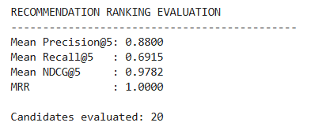
The high NDCG indicates strong agreement between the system ranking and human graded-relevance judgments, while the lower Recall@5 indicates that some human-relevant occupations were positioned outside the Top-5 recommendations.

10.4 RAG Human Evaluation
The RAG outputs were evaluated across seven dimensions: relevance, correctness, groundedness, citation correctness, completeness, clarity, and usefulness. Each dimension achieved a mean rating of 5.00/5, resulting in an overall mean rating of 5.00/5.
Furthermore, 100.00% of ratings were 4 or 5, and zero unsupported claims were identified in the 20 reviewed outputs.
Figure 21
RAG Human Evaluation Results
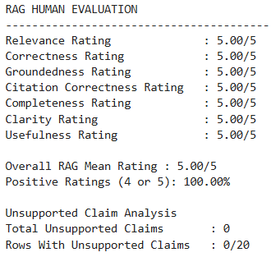
These results represent the 20-candidate human-review sample and therefore should not be interpreted as a population-wide estimate for all 63 candidates.

10.5 Consolidated Evaluation and Final Validation
The results from all four evaluation components were consolidated into the final human-evaluation summary.
Table 31
Final Human Evaluation Summary
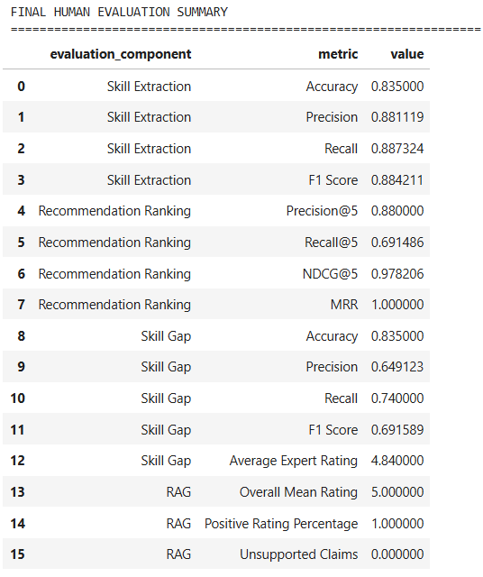
The final evaluation artifacts were exported into four CSV files covering the overall evaluation summary, candidate-level ranking metrics, RAG evaluation results, and validation status. The exported files were subsequently reloaded and checked for existence, readability, and non-empty dimensions.
Figure 22
Final Evaluation Export and Read-Back Validation
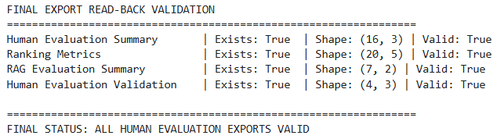
All 4/4 human-evaluation exports passed validation, confirming that the final evaluation results were successfully stored and could be independently reloaded.

Chapter 11 - Streamlit Application and Deployment

11.1 Application Architecture
The Streamlit application was developed as the user-facing deployment layer of the career recommendation system. The application integrates the validated Week 8 recommendation outputs, prescriptive skill-gap results, grounded career explanations, and completed human-evaluation results into a single interactive interface.
The application also contains a separate live demonstration pathway that allows users to enter candidate information or upload an anonymized resume. This pathway uses transparent keyword and pattern matching to extract resume information and generate live career recommendations. It is kept separate from the validated 63-candidate evaluation pipeline to avoid conflating demonstration results with experimentally evaluated results.

11.2 Data Loading and Deployment Configuration
The application uses relative project paths to access the Week 8 deployment datasets and human-evaluation results. The main datasets include the candidate deployment master, Top-5 recommendations, project KPI summary, occupation-level summary, project insights, and final human-evaluation summary.
Streamlit caching is used for dataset loading so that the application does not repeatedly reload the same files during page interactions. Error handling is also implemented to display an appropriate message and stop execution if required deployment datasets cannot be loaded.

11.3 Candidate Input and Resume Processing
The Candidate Input page supports both manual candidate-profile entry and optional resume uploading. Supported resume formats are TXT, PDF, and DOCX. The application extracts text from uploaded files and identifies selected profile attributes using keyword and pattern matching.
Extracted information includes education level, field of study, years of experience, skills, software/tools, certifications, and experience or project evidence. The extracted information is displayed to the user before recommendation generation, improving transparency and allowing the user to review the detected information.
Figure 23
Candidate profile fields and resume-derived information
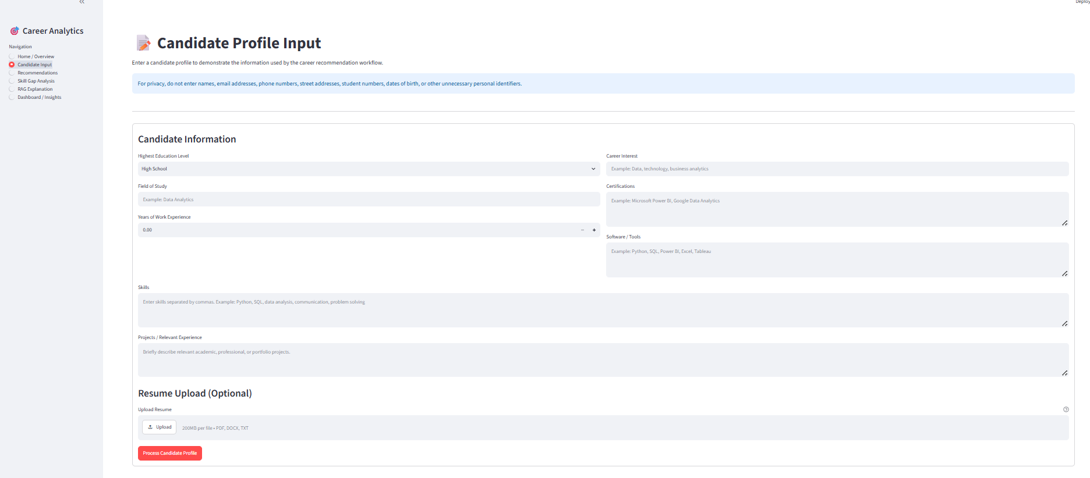
The application also includes privacy guidance advising users not to provide unnecessary personal identifiers such as names, telephone numbers, addresses, student numbers, or dates of birth.

11.4 Career Recommendation and Skill-Gap Interface
The Recommendations page presents the validated Top-1 career recommendation and its major scoring components, including overall hybrid match, skill match, semantic match, Canadian labour demand, and education alignment. The Top-5 recommendation table provides a detailed comparison of recommended occupations.
The Skill Gap Analysis page connects the recommended occupation with the identified priority skill gaps. It displays the number of missing skills, prioritized skills, highest-priority skill, and recommended development action. Candidates without priority skill gaps are explicitly identified.
This design provides a direct decision-support sequence from career recommendation to skill development planning.
Figure 24
Streamlit Recommendations Interface with Project KPI Summary
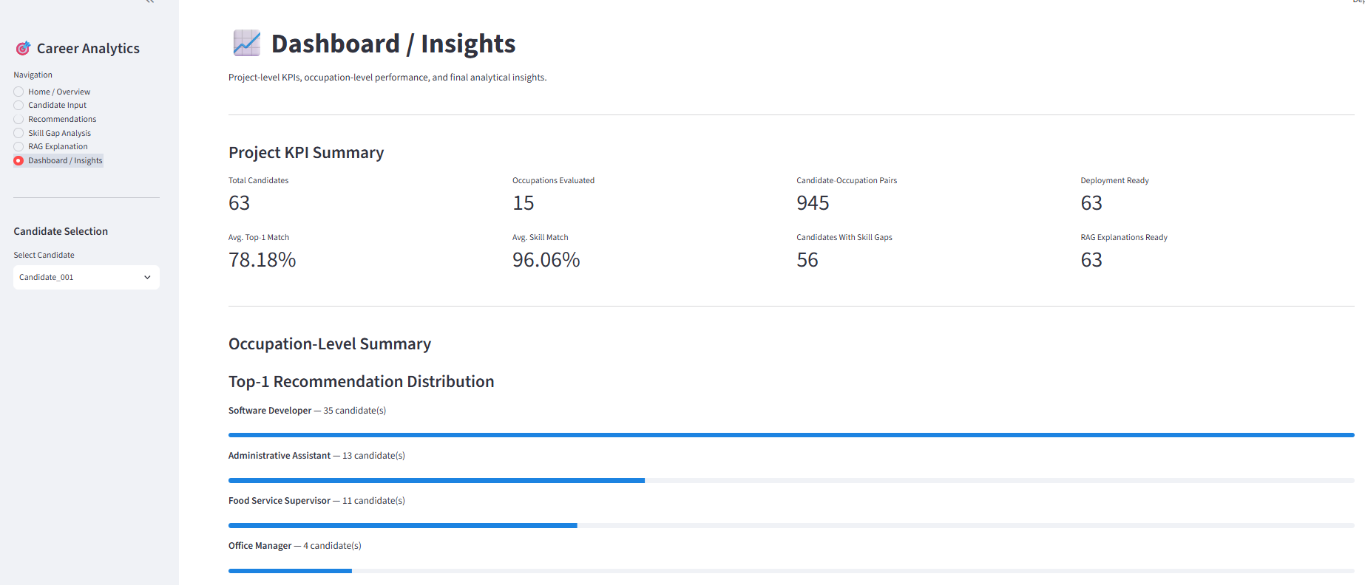

11.5 Grounded Career Explanation
The RAG Explanation page provides a grounded explanation associated with the selected Top-1 occupation. The page displays recommendation metrics together with skill-gap evidence, labour-market evidence, education alignment, and the final career explanation.
The application also checks the final RAG status and indicates whether the explanation is aligned with the final Top-1 recommendation. A decision-support limitation is provided to clarify that recommendations are not guaranteed career outcomes and should be considered together with candidate preferences, experience, labour-market conditions, and human guidance.

11.6 Dashboard and Human-Evaluation Results
The Dashboard / Insights page provides project-level and occupation-level views of the deployed system. Key indicators include the number of candidates, occupations evaluated, candidate–occupation pairs, deployment-ready candidates, average Top-1 hybrid match score, average skill match, candidates with skill gaps, and RAG explanations ready.
The dashboard also integrates the completed human-evaluation results. The displayed evaluation metrics include Skill Extraction F1, Recommendation Precision@5, Recommendation NDCG@5, Skill Gap Accuracy, average Skill Gap Expert Rating, and average RAG rating.
The application explicitly reports the evaluation sample sizes: 200 skill-extraction labels, 300 recommendation-ranking judgments, 200 skill-gap judgments, and 20 RAG explanations. The RAG results are therefore presented as findings from the reviewed sample rather than as universal performance estimates.
The final section of the dashboard displays the analytical findings and implications generated during the project, providing a consolidated view of the system's final results.
Figure 25
Streamlit Dashboard Showing Model Evaluation and Final Project Insights
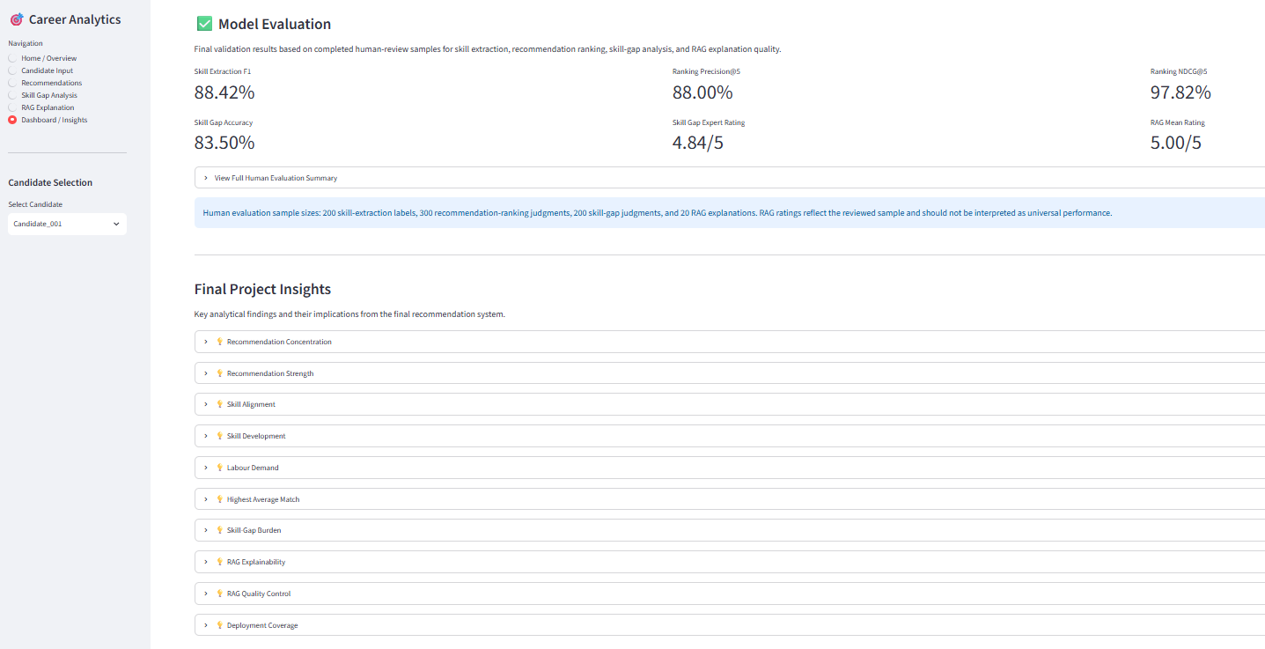

Chapter 12 - Contributions, Limitations, Future Directions, and Conclusion

12.1 Contributions of the Study
This study developed an integrated, data-driven career recommendation and skill-gap analysis system that combines candidate information with occupational, educational, and Canadian labour-market evidence.
A key contribution is the hybrid recommendation model, which combines skill match, semantic similarity, Canadian labour-market demand, and CIP education alignment to produce an overall candidate–occupation suitability score. The system evaluated 945 candidate–occupation combinations involving 63 candidates and 15 occupations.
The study also developed a prescriptive skill-gap analysis that identifies missing occupational skills and prioritizes them using O*NET skill requirements and Canadian labour-market demand. This extends the system beyond career recommendation by providing actionable skill-development guidance.
Another contribution is the source-grounded RAG explanation framework, which connects career recommendations with occupational, skill, task, labour-market, and education evidence. The developed Streamlit application integrates these capabilities into a single interactive decision-support environment.
Finally, the study incorporated human evaluation across skill extraction, recommendation ranking, skill-gap identification, and RAG explanation quality, providing empirical evidence of system performance within the available evaluation samples.

12.2 Strategic and Practical Implications
The findings have practical implications for several stakeholders.
- Candidates: For candidates, the system can identify suitable occupations and can highlight priority skills they needed for career development.
- Universities: Occupational skill and education-pathway information can support curriculum and career-oriented program planning.
- Employers: Employers can design workforce development programs and upskilling decisions based on skill-gap information.
- Career Services: For professional in Career Counselling, the system would be useful as it can provide evidence-based recommendations and personalized development pathways to support career counselling.
Overall, the project demonstrates the potential of combining career recommendation with labour-market intelligence, skill-gap analysis, and evidence-based explanations.

12.3 Limitations of the Study
The study has several limitations.
- Resume and skill extraction errors: Resume structure and terminology can affect the accuracy of extracted candidate information.
- NOC-SOC-O*NET occupation-mapping limitations: Differences between occupational classification systems may affect the precision of occupational mappings.
- Changes in labour-market demand over time: Labour-market conditions can change, reducing the long-term validity of static demand information.
- Relatively small candidate dataset: The study used 63 candidate profiles, which limits generalizability to larger and more diverse populations.
- Limited human-labelled ground-truth data for evaluation: The available human-reviewed samples were sufficient for project-level evaluation but remain limited for assessing generalizability across larger and more diverse candidate populations.
- Semantic-model limitations: Embedding-based similarity may not capture every aspect of candidate experience, transferable skills, preferences, and occupational suitability.

12.4 Future Directions
Future research can extend the system in the following areas:
- Expand the candidate dataset to improve generalizability.
- Introduce larger labelled outcome datasets to support supervised learning and outcome-based validation.
- Improve semantic recommendation models to strengthen contextual occupation matching.
- Integrate real-time labour-market APIs to provide continuously updated demand information.
- Enhance and scale the deployed Streamlit application for broader practical use.

12.5 Conclusion
This study developed an integrated career decision-support system that combined candidate profiling, occupational skills, semantic similarity, Canadian labour-market demand, education alignment, skill-gap analysis, retrieval-based evidence, and interactive deployment.
The system evaluated 63 candidates across 15 occupations. The system then demonstrated the feasibility of combining multiple evidence sources to produce personalized career recommendations and also actionable skill-development guidance. The hybrid model achieved an average Top-1 recommendation score of 78.18%, while human evaluation showed strong performance across skill extraction, recommendation ranking, skill-gap analysis, and RAG explanation quality within the evaluated samples.
The deployed Streamlit application further demonstrated the practical integration of the developed components into a user-facing career decision-support system. However, the findings in this study should be interpreted within the limitations of the available datasets, occupational mappings, semantic models, and evaluation samples.
Overall, the project provides a foundation for personalized, explainable, and evidence-based career decision support. Most importantly, this study demonstrates how data analytics and AI-oriented techniques can be applied to connect individual career profiles with occupational requirements, labour-market conditions, and targeted skill-development pathways.

References

Government of Canada. (n.d.). Job Bank. https://www.jobbank.gc.ca/
Government of Canada. (n.d.). Labour market information—Trend analysis. https://www.jobbank.gc.ca/trend-analysis
Johnson, J., Douze, M., & Jégou, H. (2017). Billion-scale similarity search with GPUs. IEEE Transactions on Big Data. https://arxiv.org/abs/1702.08734
National Center for Education Statistics. (n.d.). Classification of Instructional Programs (CIP 2020). U.S. Department of Education. https://nces.ed.gov/ipeds/cipcode/
National Center for Education Statistics. (n.d.). CIP–SOC crosswalk resources. U.S. Department of Education. https://nces.ed.gov/ipeds/cipcode/resources.aspx?y=56
National Center for ONET Development. (n.d.). ONET OnLine. U.S. Department of Labor, Employment and Training Administration. https://www.onetonline.org/
National Center for ONET Development. (n.d.). ONET Resource Center—Database downloads. U.S. Department of Labor, Employment and Training Administration. https://www.onetcenter.org/database.html
National Center for ONET Development. (n.d.). SOC 2018–ONET crosswalks. U.S. Department of Labor, Employment and Training Administration. https://www.onetcenter.org/crosswalks.html
Reimers, N., & Gurevych, I. (2019). Sentence-BERT: Sentence embeddings using Siamese BERT-networks. In Proceedings of the 2019 Conference on Empirical Methods in Natural Language Processing and the 9th International Joint Conference on Natural Language Processing (EMNLP-IJCNLP) (pp. 3982–3992). Association for Computational Linguistics. https://doi.org/10.18653/v1/D19-1410
Roy, M., & Sharma, K. (2026). AI-powered career guidance: A scalable model for personalized recommendations. IEEE Access, 14, 20927–20941. https://doi.org/10.1109/ACCESS.2026.3661573
Statistics Canada. (2021). NOC 2016 Version 1.3 to SOC 2018 (US) correspondence. https://www.statcan.gc.ca/en/statistical-programs/document/noc2016v1_3-soc2018US
Statistics Canada. (2021). NOC 2021 Version 1.0 and NOC 2016 Version 1.3 empirical concordance. https://www12.statcan.gc.ca/census-recensement/2021/ref/98-26-0007/982600072021001-eng.cfm
Statistics Canada. (2023). NOC 2016 Version 1.3 to NOC 2021 Version 1.0 correspondence table. https://www.statcan.gc.ca/en/statistical-programs/document/noc2016v1_3-noc2021v1_0
Tolegen, A. (2025). RAG for AI-powered career guidance in high schools: A pilot study. National High School Journal of Science. https://nhsjs.com/2025/rag-for-ai-powered-career-guidance-in-high-schools-a-pilot-study/
Wang, W., Wei, F., Dong, L., Bao, H., Yang, N., & Zhou, M. (2020). MiniLM: Deep self-attention distillation for task-agnostic compression of pre-trained transformers. In Advances in Neural Information Processing Systems, 33.

